Christmas lucky dip book list 2026

Reading aloud lies at the heart of literacy development, and nurturing a love of books has the power to change lives.

With this in mind, we’ve selected 16 wonderful festive stories, and produced all the resources you will need to make your own ‘Christmas lucky dip’” activity designed to create a sense of anticipation for story-time.

You can order books through your exchange, topics (subscribers only) or use the form below for any you would like to purchase.

• The books on this list can be purchased from the School Library Service
• Individual titles can be purchased at a saving of 25% off RRP
• Please contact us at schoollibraryservice@devon.gov.uk or 01392 287244

 | ISBN | Title | Author | RRP | Lucky dip picture
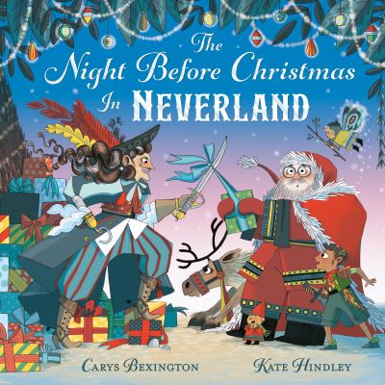 | 9781529078367 | The Night Before Christmas in Neverland | Bexington, Carys | £7.99 | 
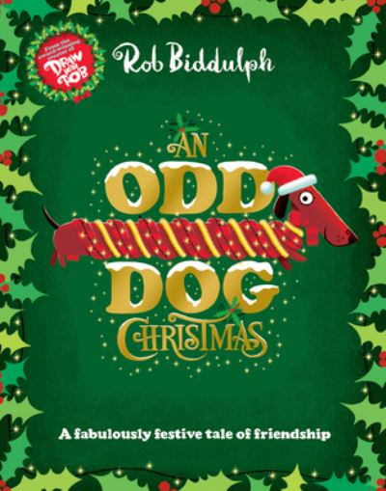 | 9780008413361 | An Odd Dog Christmas | Biddulph, Rob | £7.99 | 
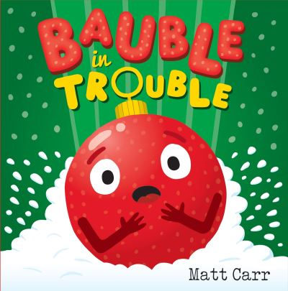 | 9781444952155 | Bauble in Trouble | Carr, Matt | £7.99 | 
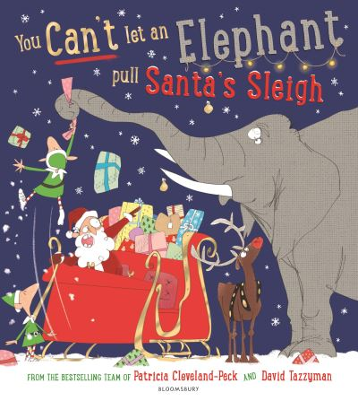 | 9781526635433 | You Can't Let an Elephant Pull Santa's Sleigh  AR: 3.5 LY | Cleveland-Peck, Patricia | £7.99 | 
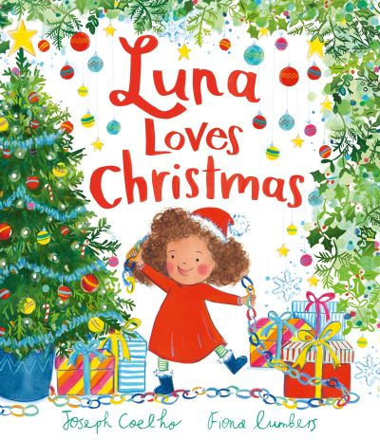 | 9781839131677 | Luna Loves Christmas | Coelho, Joseph | £7.99 | 
 | 9780008212834 | The Snowflake | Davies, Benji | £7.99 | 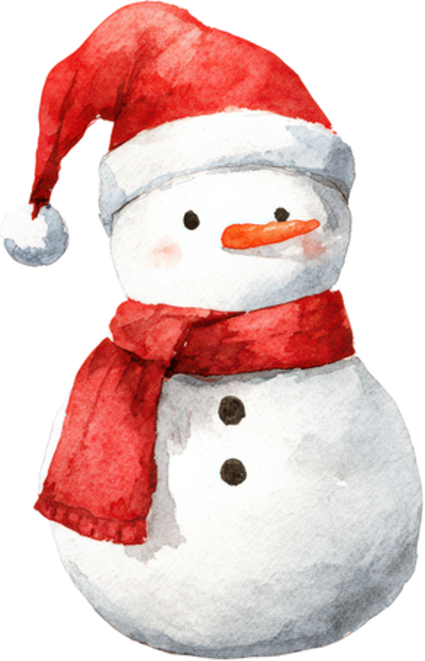
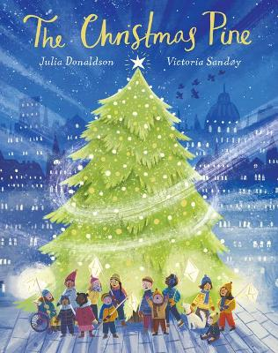 | 9780702318009 | The Christmas Pine | Donaldson, Julia | £7.99 | 
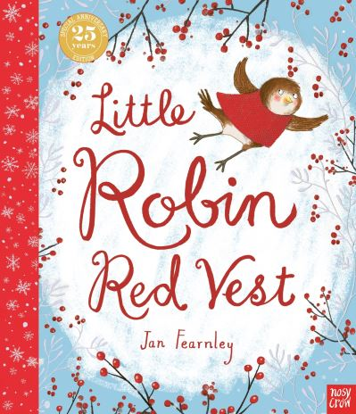 | 9781839949869 | Little Robin Red Vest  AR: 3.6 LY | Fearnley, Jan | £7.99 | 
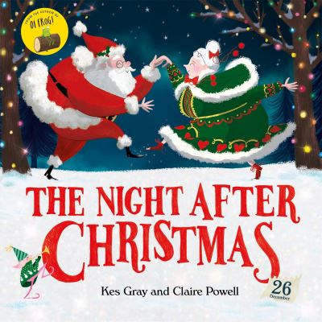 | 9781444954661 | The Night After Christmas  AR: 3.3 LY | Gray, Kes | £6.99 | 
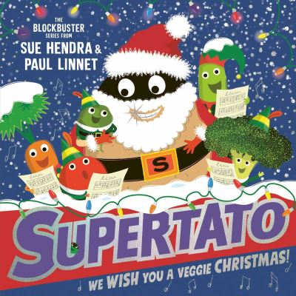 | 9781398532151 | We Wish You a Veggie Christmas  AR: 3.1 LY | Hendra, Sue | £7.99 | 
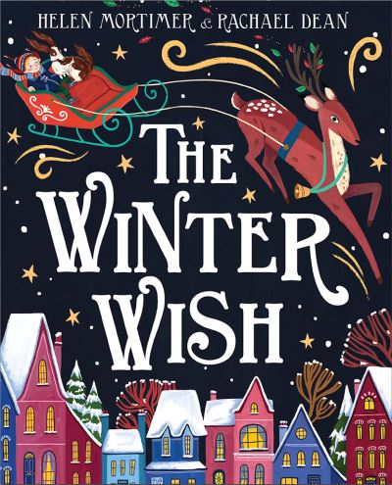 | 9780008497606 | The Winter Wish | Mortimer, Helen | £7.99 | 
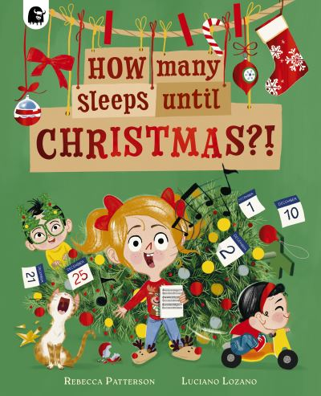 | 9781836003014 | How Many Sleeps Until Christmas?! | Patterson, Rebecca | £7.99 | 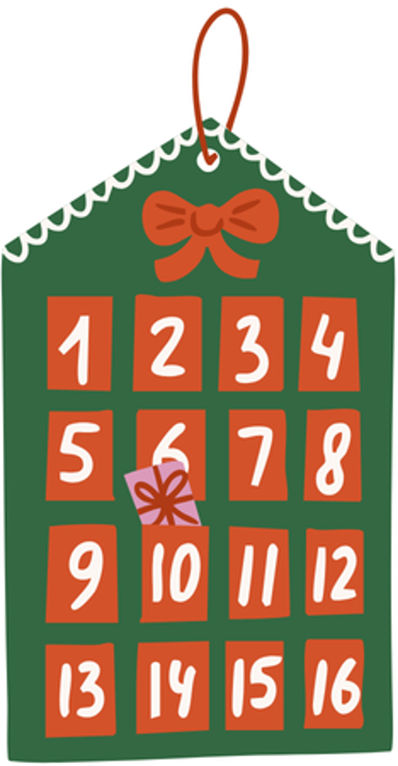
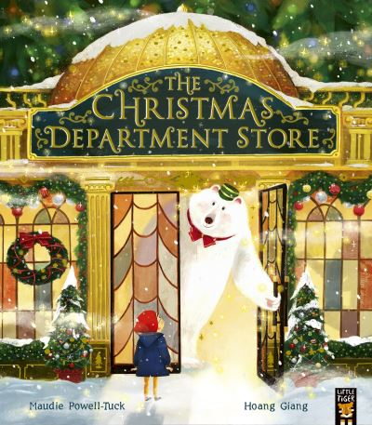 | 9781801040129 | The Christmas Department Store | Powell-Tuck, Maudie | £7.99 | 
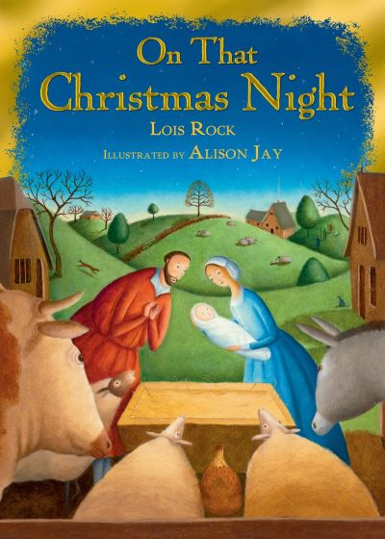 | 9780745965093  NF 232.92 | On That Christmas Night | Rock, Lois | £7.99 | 
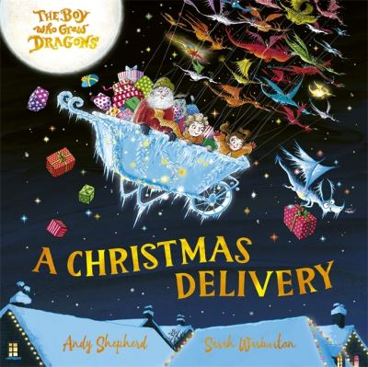 | 9781835874264 | A Christmas Delivery | Shepherd, Andy | £7.99 | 
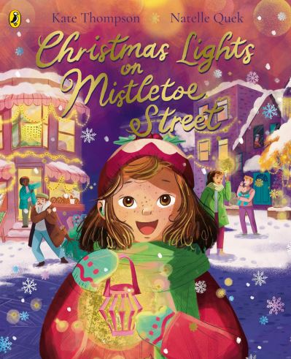 | 9780241621189 | Christmas Lights on Mistletoe Street | Thompson, Kate | £7.99 | 

