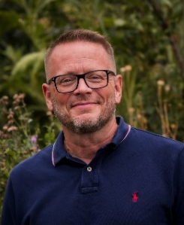
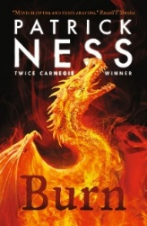
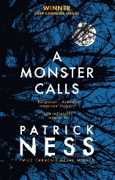
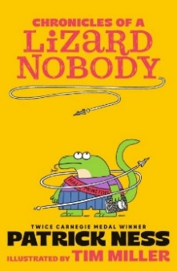
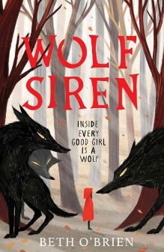
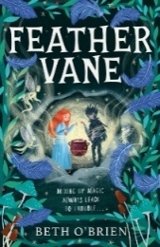
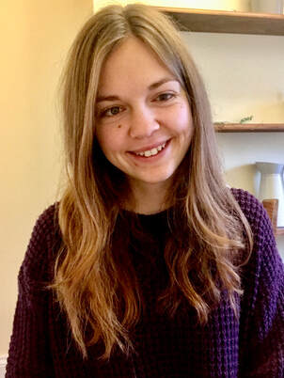
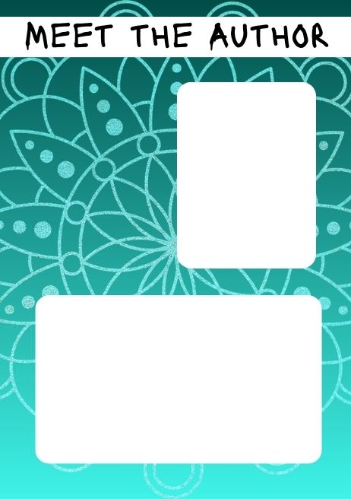
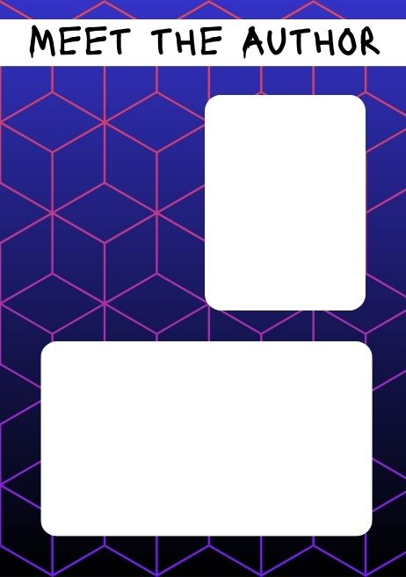
Patrick Ness
Beth O’Brien
Beth O’Brien is a poet and children’s author. Born with a visual impairment and an upper-limb difference, she is passionate about the representation of disability in literature. Beth is the founder of Disabled Tales, a website dedicated to discussing disability in fairytales and folklore.

Patrick Ness is a multi-award-winning author of 3 adult and 11 young adult novels. The Chronicles of a Lizard Nobody, a two-book series, marks his first fiction written specifically for younger children. He wrote a screenplay for A Monster Calls and is a two-time Carnegie Medal winner.


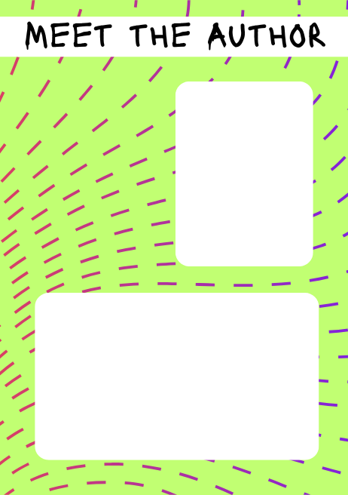
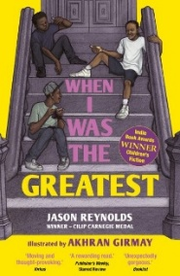
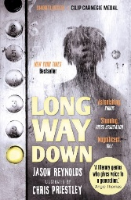
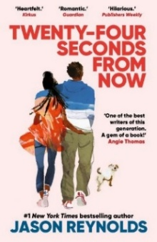
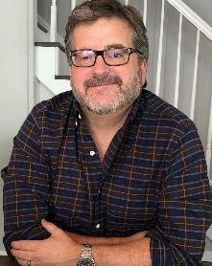
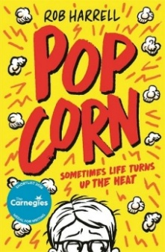
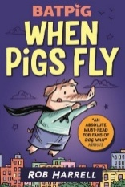
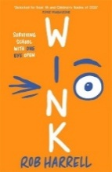
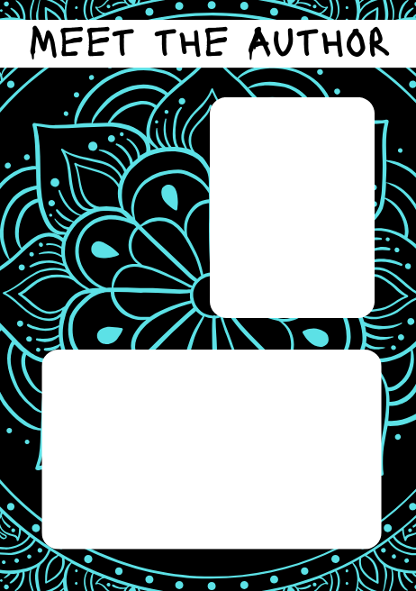
Jason Reynolds
Jason Reynolds is a multi-award-winning author of poetry and teen fiction. He began his writing life in poetry and published several poetry collections before releasing his first novel in 2014. Since then, he has written numerous acclaimed novels, including works told in verse.

Rob Harrell
Rob Harrell is the author of graphic novels and children’s fiction. His works include Monster on the Hill, which was adapted into the animated film Rumble. He creates a daily online comic strip. Rob’s latest novel, Popcorn, draws on his own experiences of managing childhood anxiety.

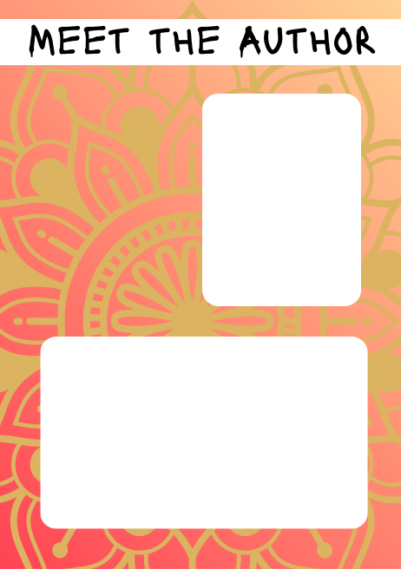
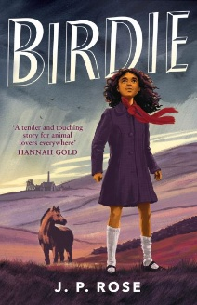
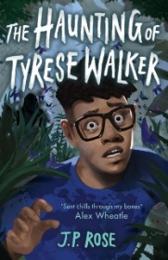
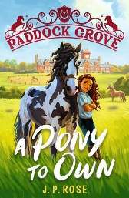
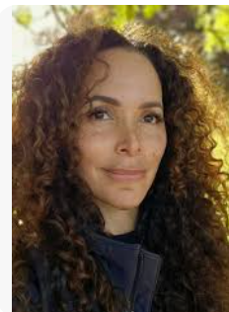
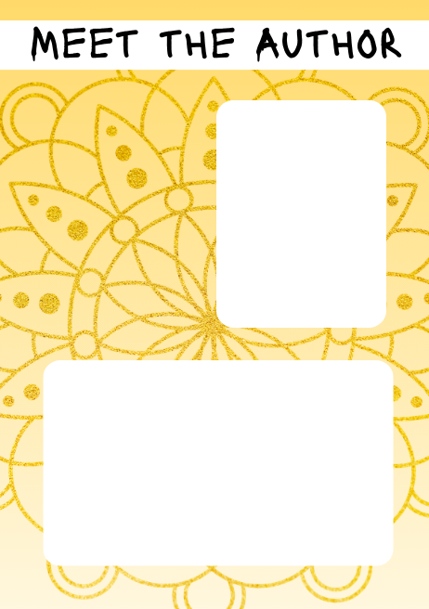
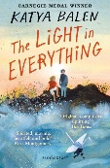
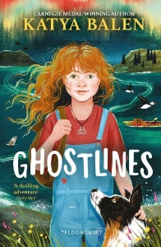
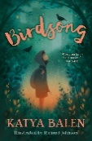
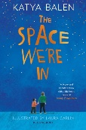
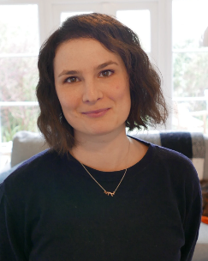
Katya Balen
J P Rose
J. P. Rose has written many books for adults and has now started writing for children. From a young age, she was always jotting down ideas and stories, driven by the lack of books featuring Black, adopted children from Yorkshire like herself.

Katya Balen is the author of numerous children’s books, known for their brave, bold characters and deep connections with nature. Before becoming a writer, Katya worked in special schools, social care and ran a small charity offering creative workshops for neurodivergent people.

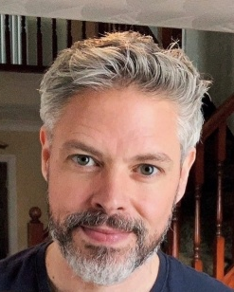

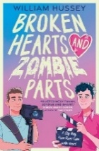
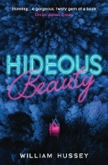
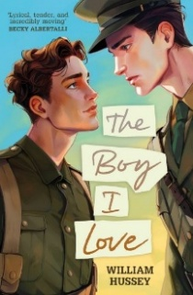
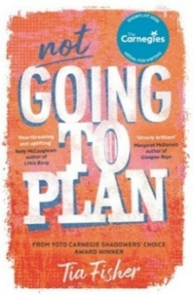
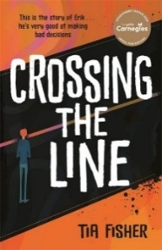
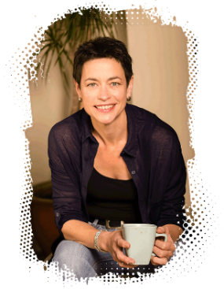
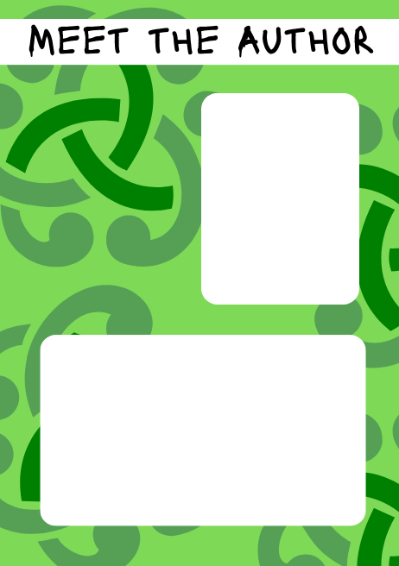
William Hussey
Tia Fisher
William Hussey is an award-winning author of numerous teen and adult fiction titles. He has spent many years visiting schools, teaching creative writing to young people, and leading workshops on LGBTQ+ lives and fundamental human rights. He now lives in Dumfries with his partner and their dog, Bucky.

Tia Fisher loves writing books that tackle important issues for young people. From an early age she read avidly. When she wasn’t reading, she was writing poetry, often about unrequited love or protest. She recently returned to university to earn a master’s degree in writing for young people.

