SEN booklist 2025 - non-fiction

- The books on this list can be purchased from the School Library Service
- Individual titles can be purchased at a saving of 25% off RRP
- Please contact us at schoollibraryservice@devon.gov.uk or 01392 287244

 | ISBN | Title | Author | RRP
 |  | Non-fiction
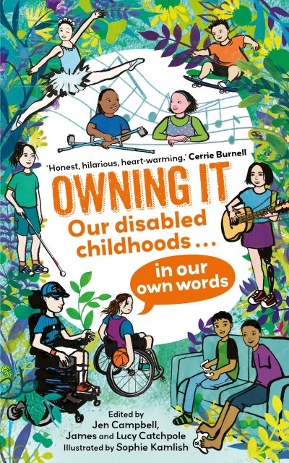 | 9780571380022  NF 362.1 | Owning It: Our Disabled Childhoods...in Our Own Words |  | £12.99
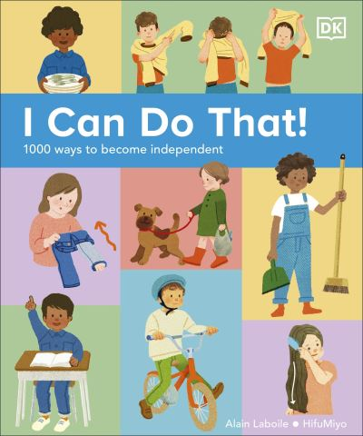 | 9780241634950  NF 158.1  SEND | I Can Do That! |  | £14.99
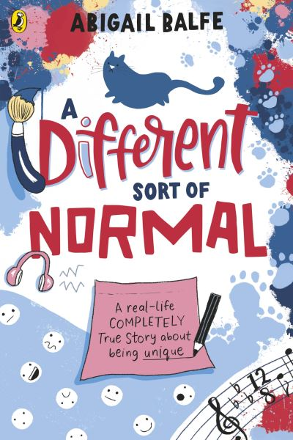 | 9780241508794  NF 616.858  ASD | A Different Sort of Normal  AR: 6.9 MY | Balfe, Abigail | £8.99
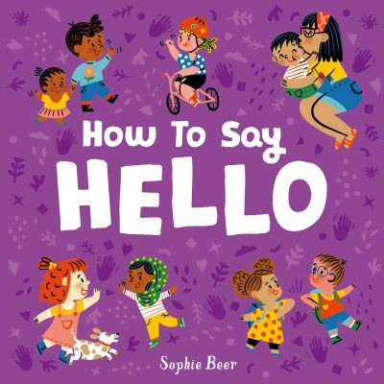 | 9781838914158  NF 302.222  SEND | How to Say Hello | Beer, Sophie | £7.99
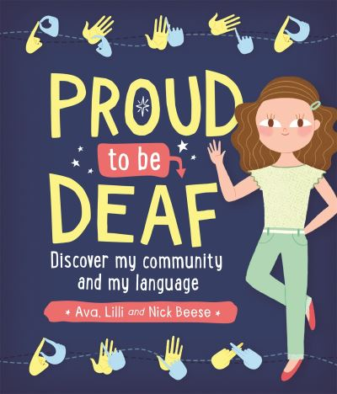 | 9781526302199  NF 362.42  H I | Proud to be Deaf  AR: 5.6 LY | Beese, Ava | £8.99
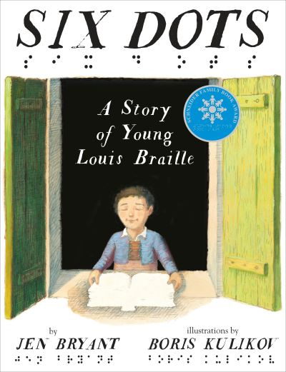 | 9780449813379  NF 920  V I | Six Dots | Bryant, Jen | £15.99
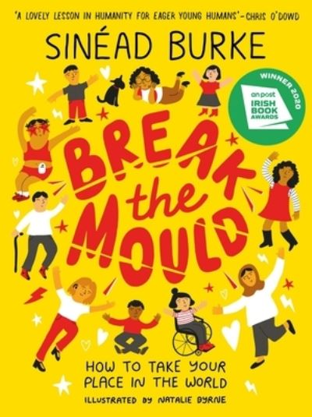 | 9781526363336  NF 158.1  SEND | Break the Mould : How to Take Your Place in the World  BB: Dark Blue | Burke, Sinead | £9.99
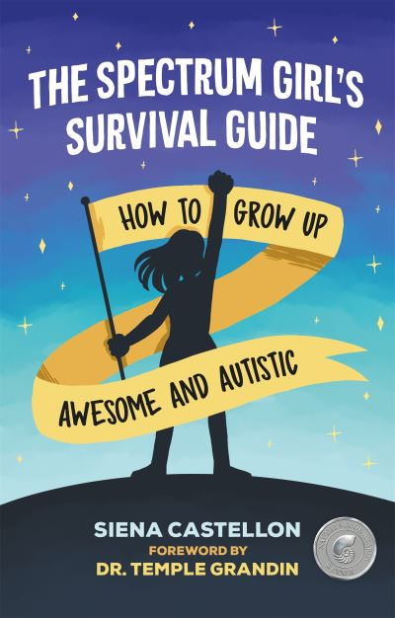 | 9781787751835  NF 305.90  ASD | The Spectrum Girl’s Survival Guide | Castellon, Siena | £14.99
 | 9781445172903  NF 920  ASD | Greta Thunberg and the Climate Crisis  BB: Dark Blue | Chapman, Amy | £8.99
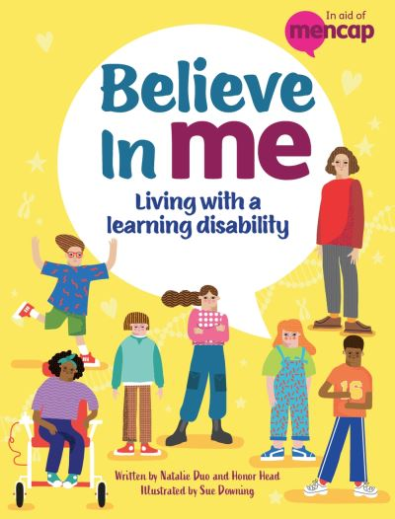 | 9781445187341  NF 616.858  SEND | Believe In Me | Duo, Natalie | £9.99
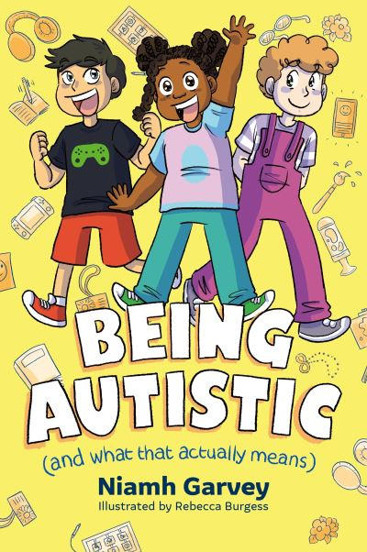 | 9781805011712  NF 362.19  ASD | Being Autistic (and What that Actually Means) | Garvey, Niamh | £10.99
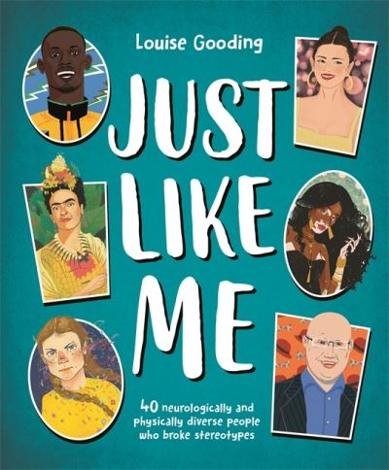 | 9781800784321  NF 920.008  SEND | Just Like Me | Gooding, Louise | £9.99
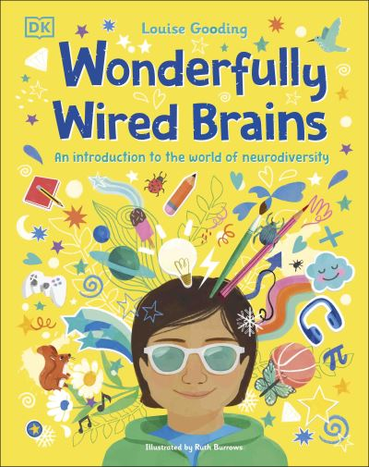 | 9780241568163  NF 616.858  Neurodiversity | Wonderfully Wired Brains | Gooding, Louise | £12.99
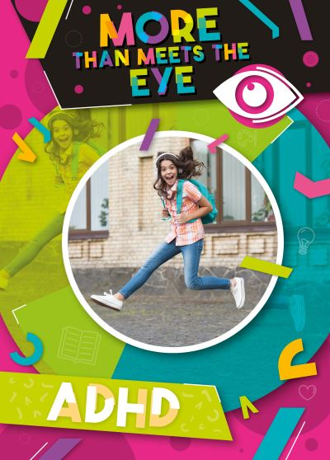 | 9781805053606  NF 616.858  ADHD | ADHD  AR: 5.7 MY | Holmes, Kirsty | £9.99
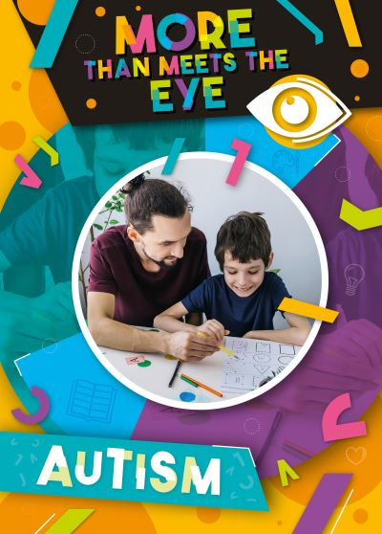 | 9781805056690  NF 616.858  ASD | Autism  AR: 6.2 MY | Holmes, Kirsty | £9.99
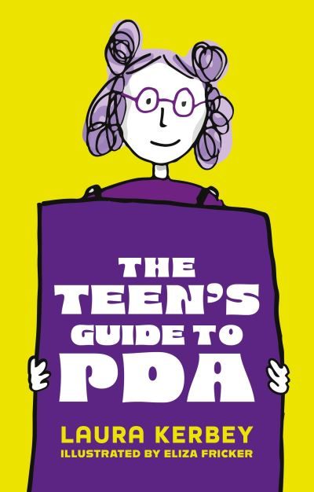 | 9781805011835  NF 616.858  ASD | The Teen’s Guide to PDA | Kerbey, Laura | £14.99
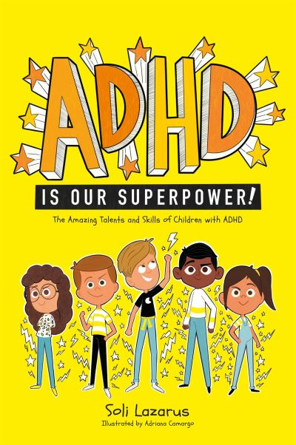 | 9781787757301  NF 616.858  ADHD | ADHD Is Our Superpower: The Amazing Talents and Skills of Children with ADHD | Lazarus, Soli | £10.99
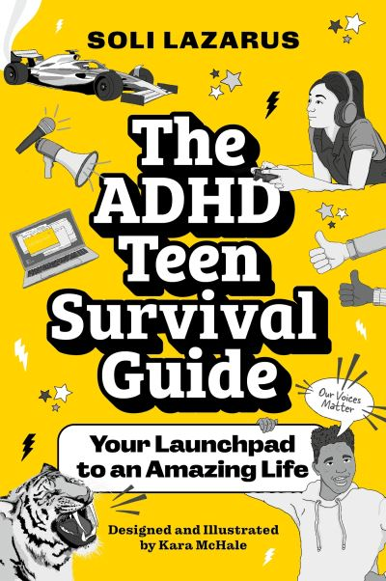 | 9781839976636  NF 616.858  ADHD | The ADHD Teen Survival Guide: Your Launchpad to an Amazing Life | Lazarus, Soli | £12.99
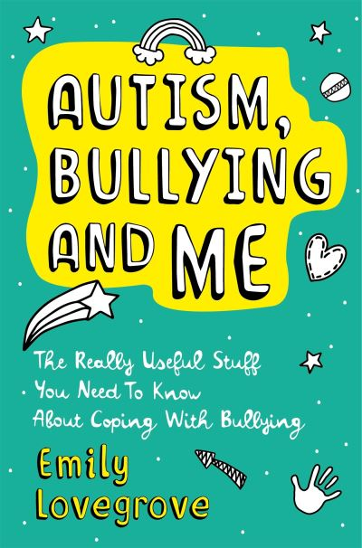 | 9781787752139  NF 302.343  ASD | Autism, Bullying and Me | Lovegrove, Emily | £14.99
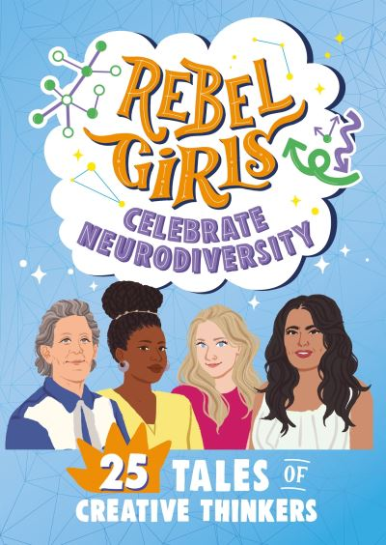 | 9798889641094  NF 920  Neurodiversity | Rebel Girls Celebrate Neurodiversity | Mallory, Shadae | £6.99
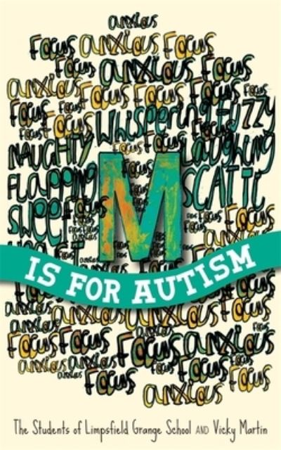 | 9781849056847  NF 616.858  ASD | M is for Autism | Martin, Vicky | £12.99
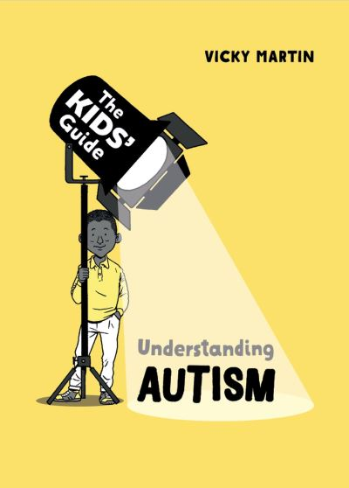 | 9781445182841  NF 616.858  ASD | Understanding Autism | Martin, Vicky | £9.99
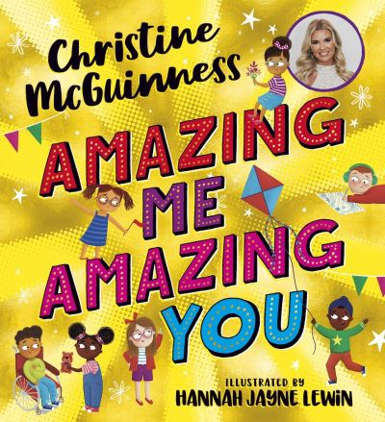 | 9780702323201  NF 616.858  ASD | Amazing Me, Amazing You | McGuinness, Christine | £7.99
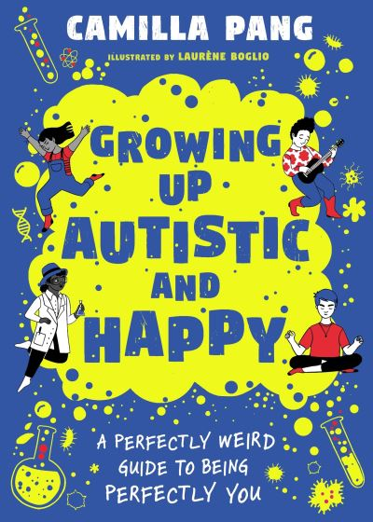 | 9781526366702  NF 155.412  ASD | Growing Up Autistic and Happy | Pang, Camilla | £9.99
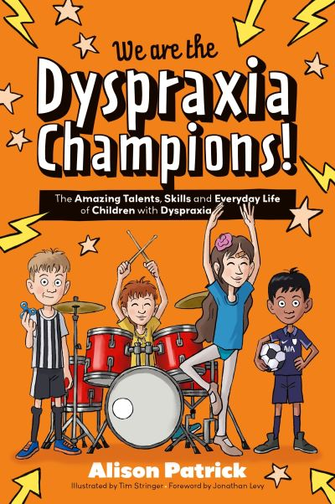 | 9781839979101  NF 616.858  SEND | We are the Dyspraxia Champions!: The Amazing Talents, Skills and Everyday Life of Children with Dyspraxia | Patrick, Alison | £10.99
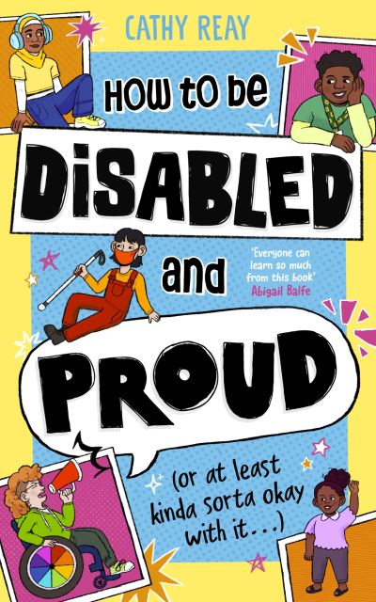 | 9780241676967  NF 362.4 | How to be Disabled and Proud | Reay, Cathy | £12.99
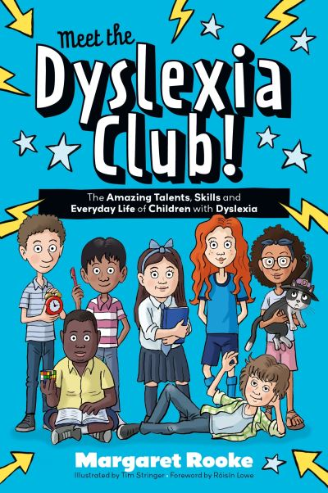 | 9781839978432  NF 616.855  SEND | Meet the Dyslexia Club!: The Amazing Talents, Skills and Everyday Life of Children with Dyslexia | Rooke, Margaret | £10.99
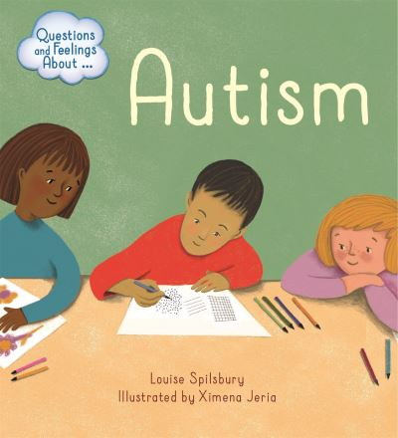 | 9781445156590  NF 616.858  ASD | Autism | Spilsbury, Louise | £8.99
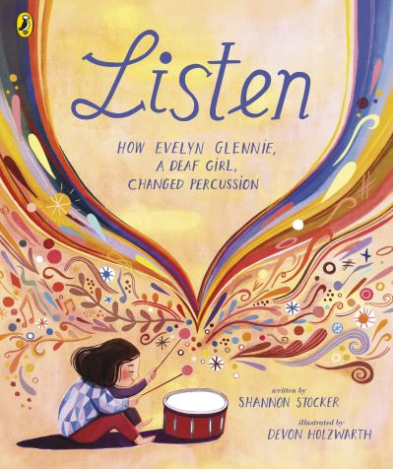 | 9780241547687  NF 920  H I | Listen  AR: 3.7 LY | Stocker, Shannon | £7.99
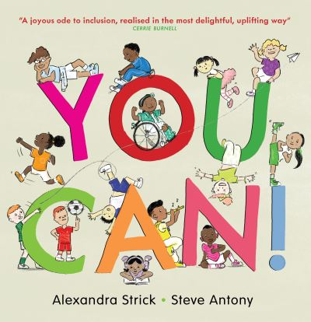 | 9781913074609  NF 158.1  Neurodiversity | You Can! | Strick, Alexandra | £12.99
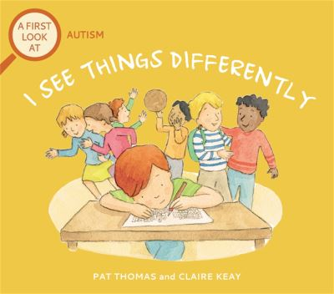 | 9781526317599  NF 616.858  ASD | I See Things Differently | Thomas, Pat | £8.99
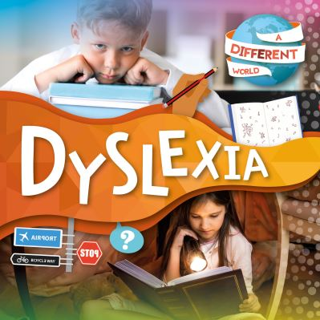 | 9781839271342  NF 616.855  Dyslexia | Dyslexia  BB: Orange | Twiddy, Robin | £8.99
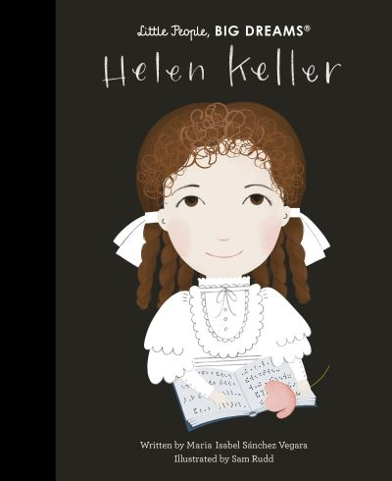 | 9780711259522  NF 920  V I and H I | Helen Keller  AR: 5.2 LY | Vegara, Maria Isabel Sanchez | £9.99
 | 9780711257733  NF 920  V I | Stevie Wonder  AR: 2.7 LY | Vegara, Maria Isabel Sanchez | £9.99
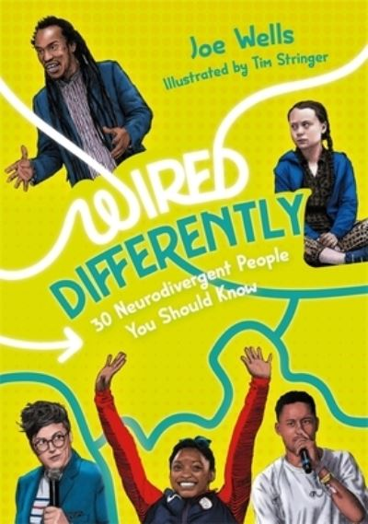 | 9781787758421  NF 920.008  Neurodiversity | Wired Differently | Wells, Joe | £16.99
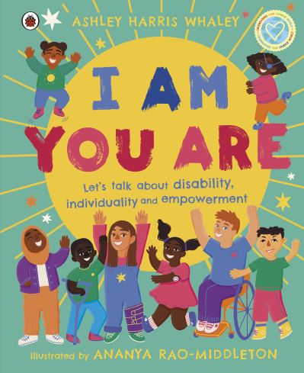 | 9780241573112  NF 362.1  Disability | I Am, You Are | Whaley, Ashley Harris | £12.99

