SEN booklist - picture books

- The books on this list can be purchased from the School Library Service
- Individual titles can be purchased at a saving of 25% off RRP
- Please contact us at schoollibraryservice@devon.gov.uk or 01392 287244

 | ISBN | Title | Author | RRP
 |  | Younger Picture Books
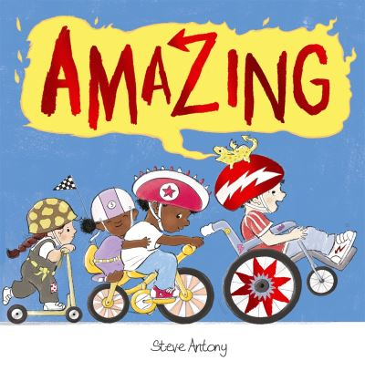 | 9781444944716  Physical Disability | Amazing | Antony, Steve | £7.99
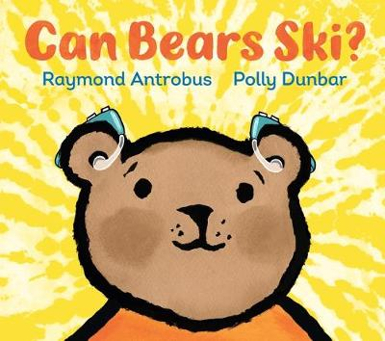 | 9781406394627  H I | Can Bears Ski?  AR: 2.4 LY | Antrobus, Raymond | £7.99
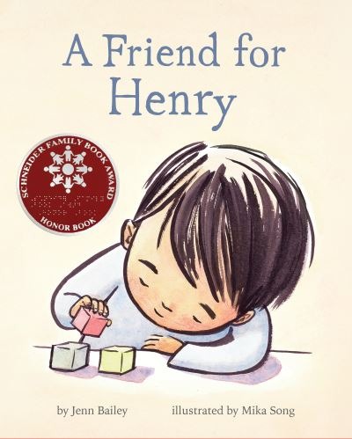 | 9781452167916  ASD | A Friend for Henry  AR: 2.4 LY | Bailey, Jenn | £12.99
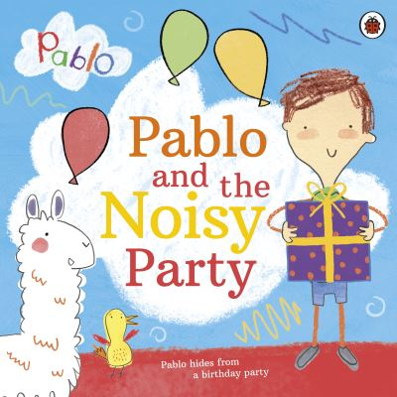 | 9780241415740  ASD | Pablo and the Noisy Party | Brenner, Andrew | £7.99
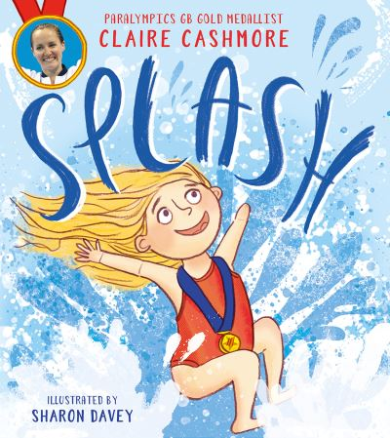 | 9780755502851  Physical Disability | Splash | Cashmore, Claire | £7.99
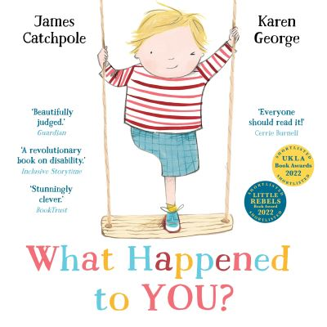 | 9780571358311  Physical Disability | What Happened to You?  AR: 2.0 LY | Catchpole, James | £7.99
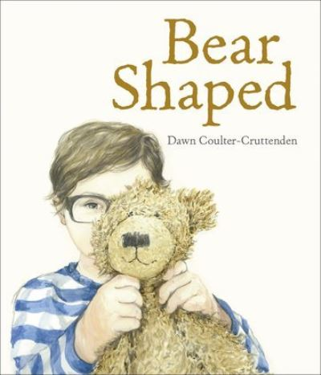 | 9780192772114  ASD | Bear Shaped  AR: 3.3 LY | Coulter-Cruttenden, Dawn | £7.99
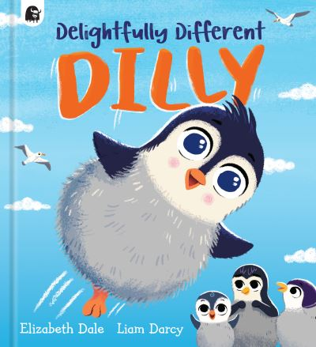 | 9780711259607  Physical Disability | Delightfully Different Dilly  AR: 2.7 LY | Dale, Elizabeth | £6.99
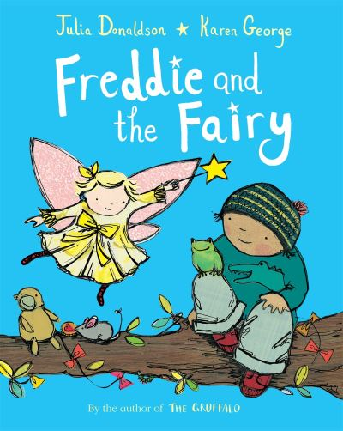 | 9781529042528  H I | Freddie and the Fairy  AR: 2.2 LY | Donaldson, Julia | £7.99
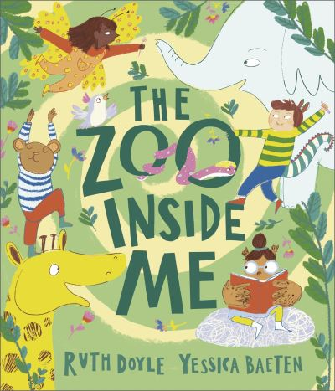 | 9781839131455  Neurodiversity | The Zoo Inside Me | Doyle, Ruth | £7.99
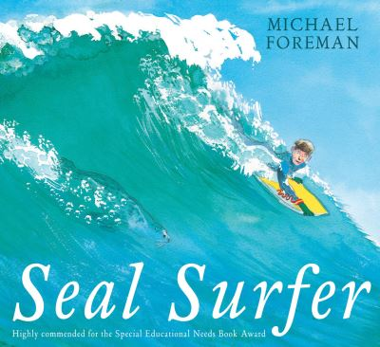 | 9781842705780  Physical Disability | Seal Surfer  AR: 4.1 LY | Foreman, Michael | £7.99
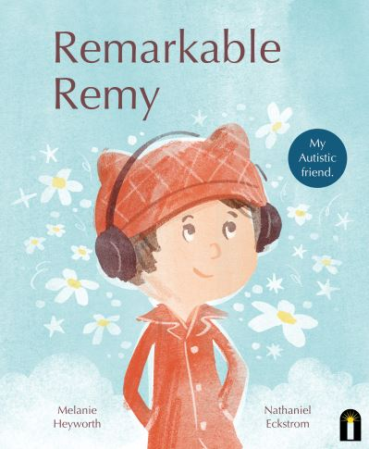 | 9781761210372  ASD | Remarkable Remy | Heyworth, Melanie | £9.99
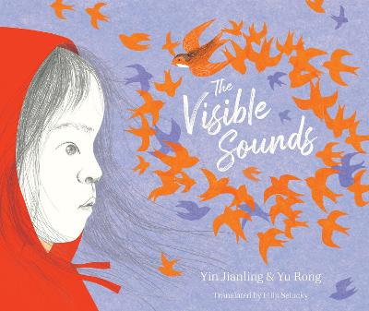 | 9781912979790  H I | The Visible Sounds  AR: 3.4 LY | Jianling, Yin | £7.99
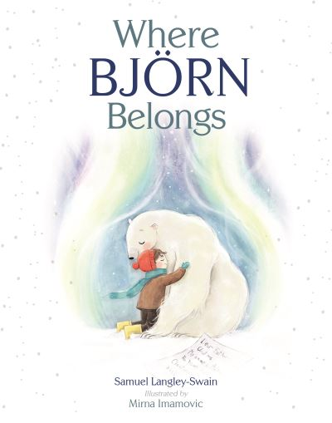 | 9781913339449  Neurodiversity | Where Bjorn Belongs | Langley-Swain, Samuel | £7.99
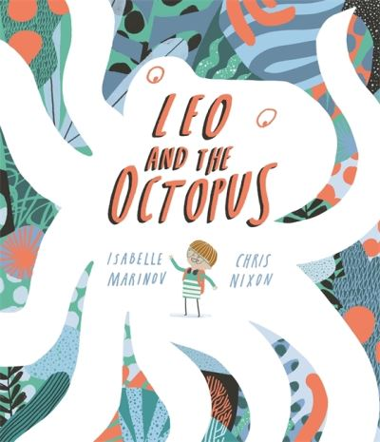 | 9781787416550  ASD | Leo and the Octopus | Marinov, Isabelle | £7.99
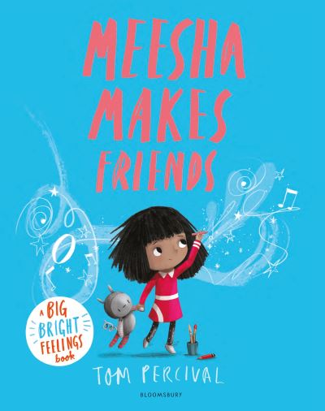 | 9781526612953  Neurodiversity | Meesha Makes Friends  AR: 2.6 LY  BB: Purple | Percival, Tom | £7.99
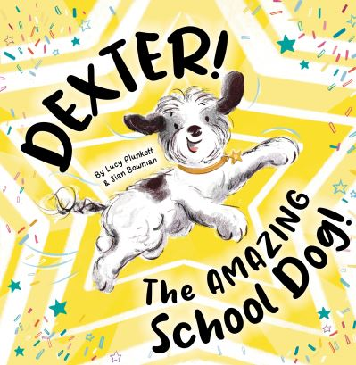 | 9781913339500  Neurodiversity | Dexter, the Amazing School Dog | Plunkett, Lucy | £7.99
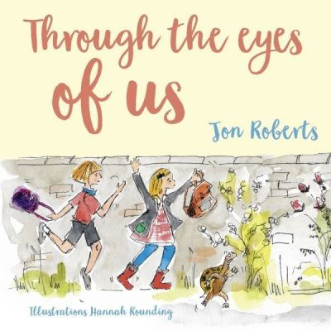 | 9781802586138  ASD | Through the Eyes of Us | Roberts, Jon | £7.99
 | 9781802584103  ASD | The Torch | Roberts, Jon | £7.99
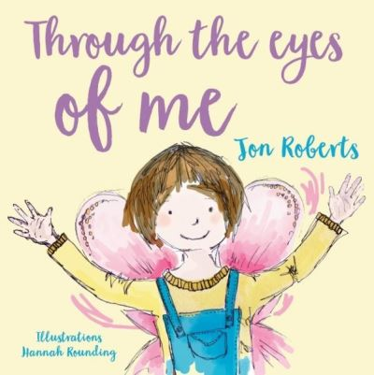 | 9781912213009  ASD | Through the Eyes of Me | Roberts, Jon | £7.99
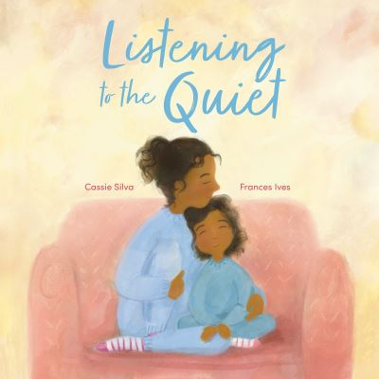 | 9781915244482  H I | Listening to the Quiet | Silva, Cassie | £12.99
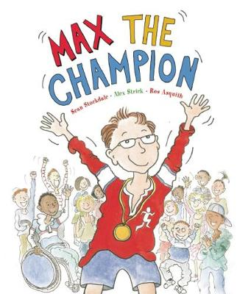 | 9781847805195  Disability | Max the Champion | Stockdale, Sean | £8.99
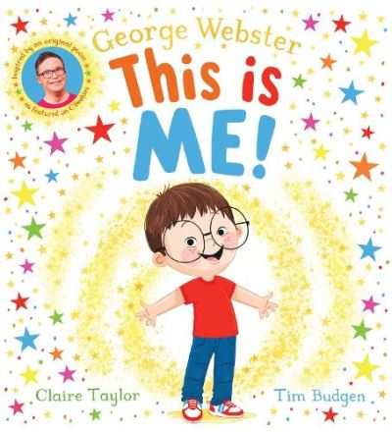 | 9780702319143  Downs Syndrome | This is Me! | Webster, George | £7.99
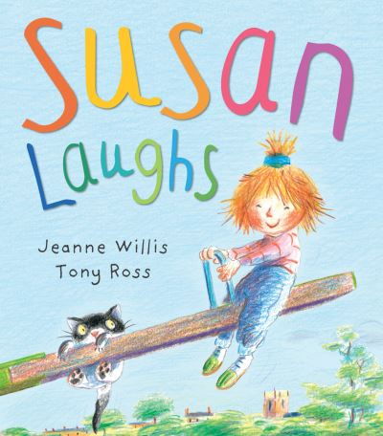 | 9781842709900  Disability | Susan Laughs  BB: Pink | Willis, Jeanne | £7.99
 |  | Older Picture Books
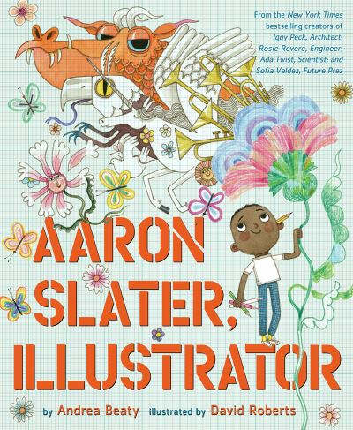 | 9781419753961  Dyslexia | Aaron Slater, Illustrator | Beaty, Andrea | £13.99
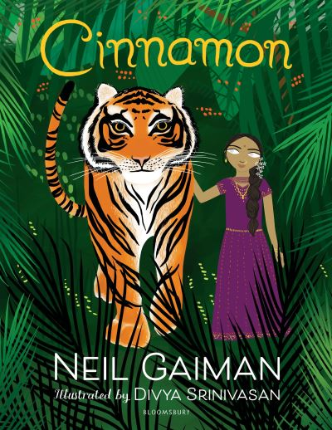 | 9781408879221  V I | Cinnamon  AR: 5.1 LY  BB: Brown | Gaiman, Neil | £7.99

