SEN booklist 2025 - teen

- The books on this list can be purchased from the School Library Service
- Individual titles can be purchased at a saving of 25% off RRP
- Please contact us at schoollibraryservice@devon.gov.uk or 01392 287244

 | ISBN | Title | Author | RRP
 |  | Younger Teen
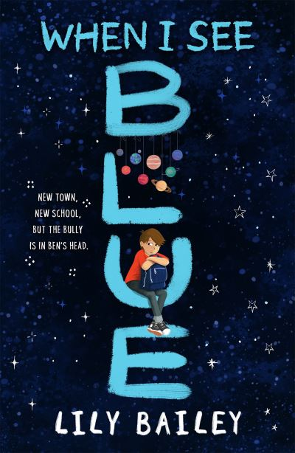 | 9781510109803  OCD | When I See Blue  AR: 5.5 MY | Bailey, Lily | £7.99
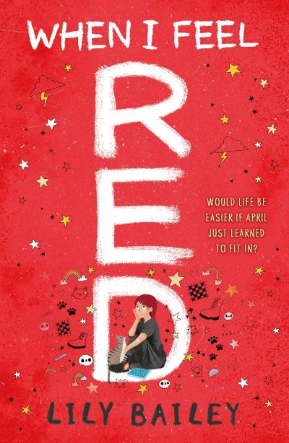 | 9781510109933  Dyspraxia | When I Feel Red  AR: 5.6 MY | Bailey, Lily | £8.99
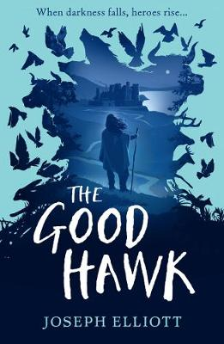 | 9781406385854  Downs Syndrome | The Good Hawk  AR: 4.3 MY | Elliott, Joseph | £8.99
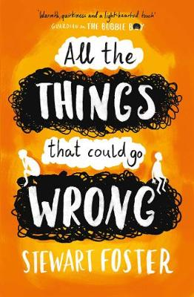 | 9781471145421  OCD | All the Things that Could Go Wrong  AR: 3.9 MY+  BB: Dark Red | Foster, Stewart | £7.99
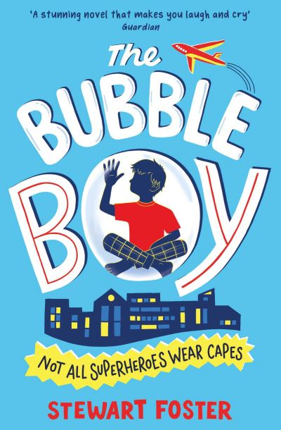 | 9781471145407  Immune System Disorder | The Bubble Boy  AR: 3.6 MY | Foster, Stewart | £7.99
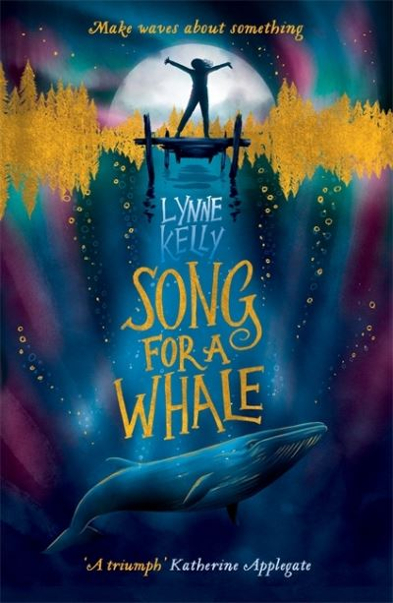 | 9781848126916  H I | Song for a Whale  AR: 5.3 MY | Kelly, Lynne | £7.99
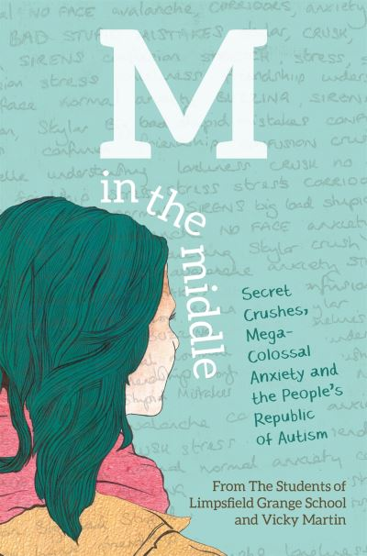 | 9781785920349  ASD | M in the Middle | Martin, Vicky | £12.99
 | 9781444949278  ASD | Bookishly Ever After | Powrie, Lucy | £8.99
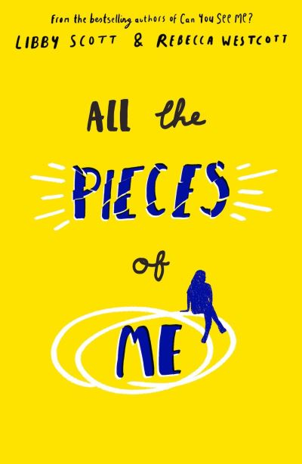 | 9780702317415  ASD | All the Pieces of Me  AR: 5.8 MY+ | Scott, Libby | £7.99
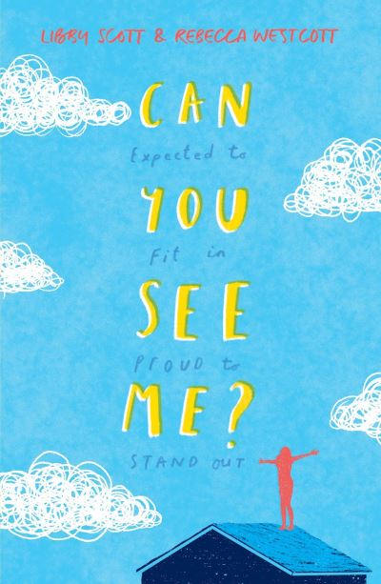 | 9781407195674  ASD | Can You See Me?  AR: 5.6 MY  BB: Dark Red | Scott, Libby | £7.99
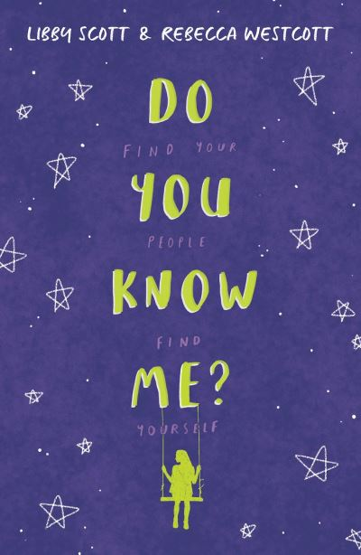 | 9780702300950  ASD | Do You Know Me?  AR: 5.7 MY  BB: Dark Red | Scott, Libby | £7.99
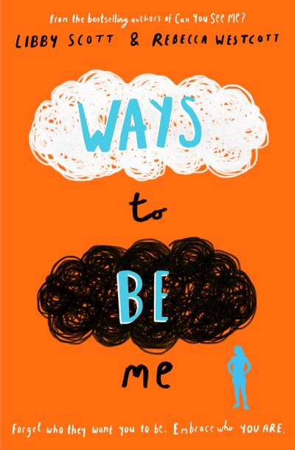 | 9780702308352  ASD | Ways To Be Me  AR: 5.5 MY  BB: Dark Red | Scott, Libby | £7.99
 |  | Older Teen
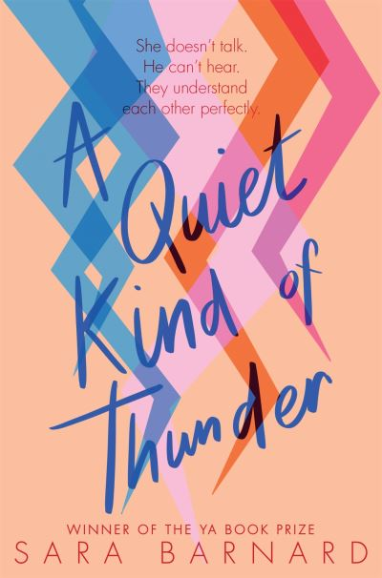 | 9781529037586  Selective Mutism and H I | A Quiet Kind of Thunder  AR: 4.4 UY | Barnard, Sara | £8.99
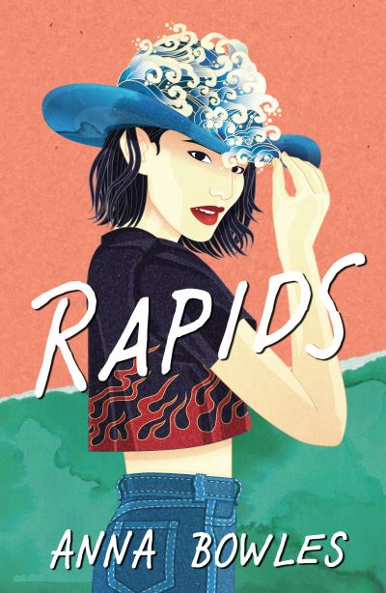 | 9781916204232  Bipolar Disorder | Rapids | Bowles, Anna | £9.99
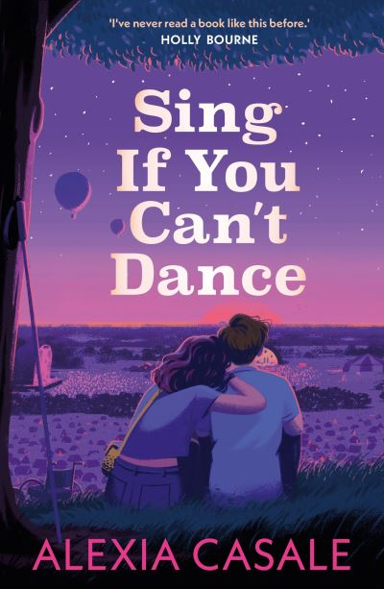 | 9780571373802  Undiagnosed Chronic Illness | Sing If You Can't Dance  AR: 6.0 UY | Casale, Alexia | £8.99
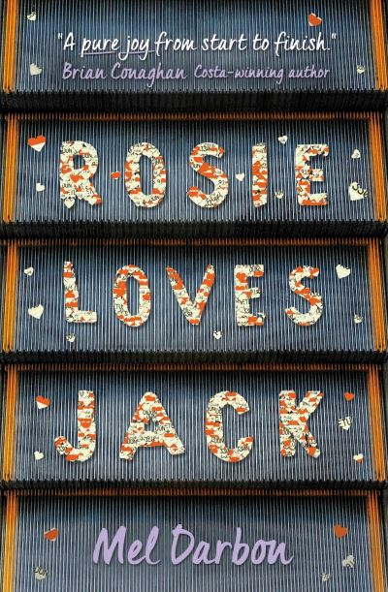 | 9781474937832  Downs Syndrome | Rosie Loves Jack  AR: 3.3 UY | Darbon, Mel | £8.99
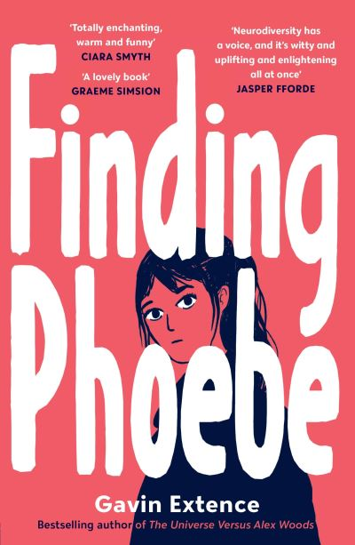 | 9781839133312  ASD | Finding Phoebe  AR: 5.6 UY | Extence, Gavin | £8.99
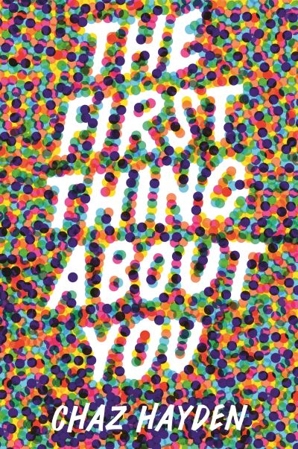 | 9781529510942  Spinal Muscular Atrophy | The First Thing About You  AR: 4.7 UY | Hayden Chas | £8.99
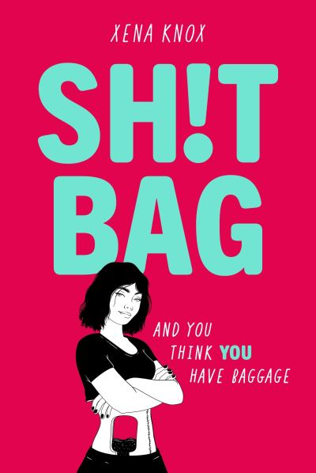 | 9781444972054  Bowel Disease | Sh!t Bag | Knox, Xena | £9.99

