SEN booklist 2025 - junior fiction

- The books on this list can be purchased from the School Library Service
- Individual titles can be purchased at a saving of 25% off RRP
- Please contact us at schoollibraryservice@devon.gov.uk or 01392 287244

 | ISBN | Title | Author | RRP
 |  | Junior Fiction
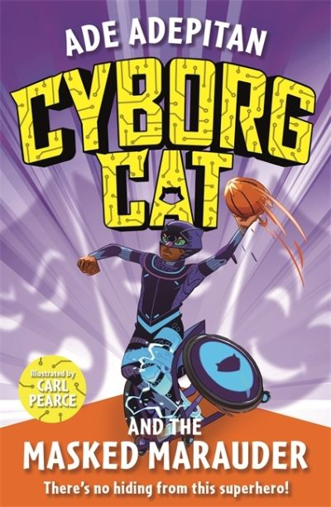 | 9781848128507  Disability | Cyborg Cat and the Masked Marauder  BB: Grey | Adepitan, Ade | £5.99
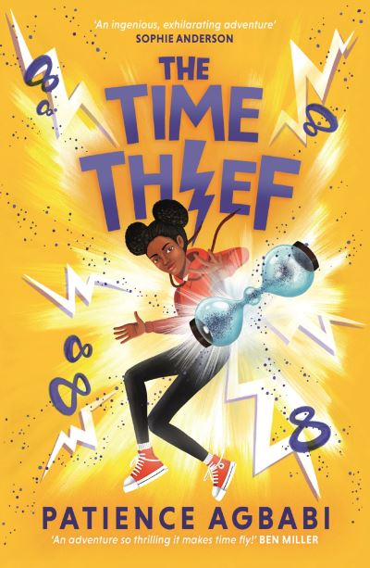 | 9781786899903  ASD/ADHD | The Time Thief  AR: 5.1 MY  BB: Dark Red | Agbabi, Patience | £7.99
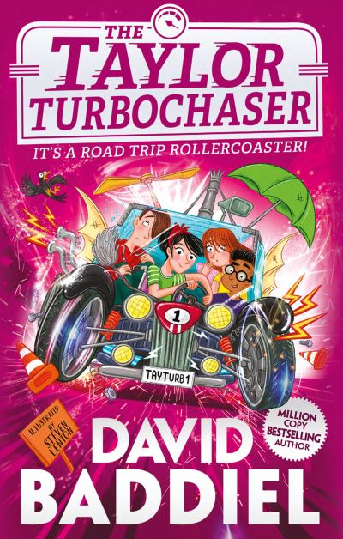 | 9780008365387  Disability | The Taylor Turbochaser  AR: 3.9 MY  BB: Dark Blue | Baddiel, David | £7.99
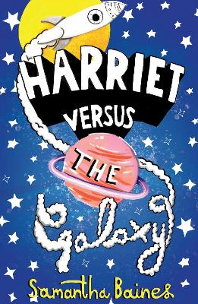 | 9781913311018  H I | Harriet Versus the Galaxy  BB: Grey | Baines, Samantha | £6.99
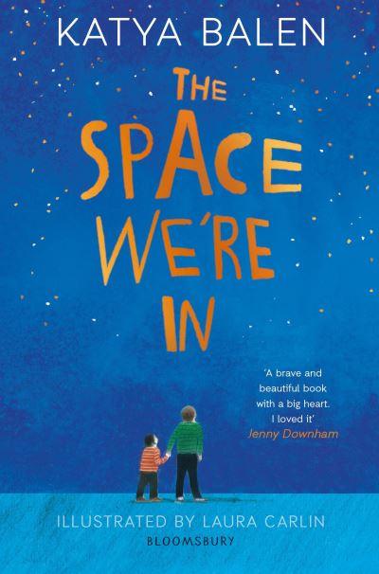 | 9781526601971  ASD | The Space We're In  AR: 5.7 MY  BB: Dark Red | Balen, Katya | £7.99
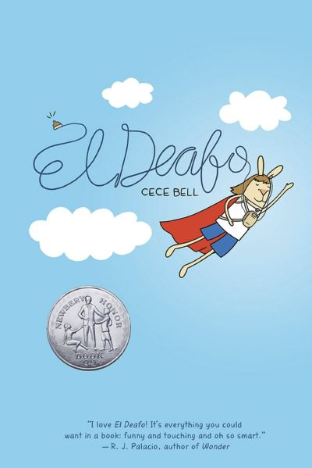 | 9781419712173  H I | El Deafo  Graphic  AR: 2.7 MY  BB: Dark Blue | Bell, Cece | £11.99
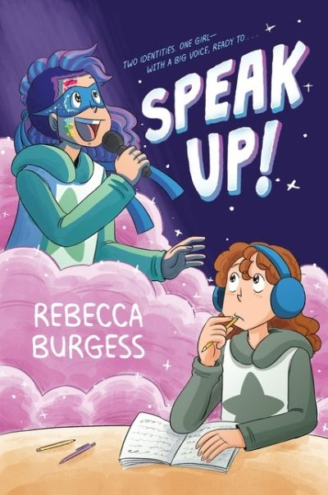 | 9780063081192  ASD | Speak up!  Graphic  AR: 3.2 MY | Burgess, Rebecca | £10.99
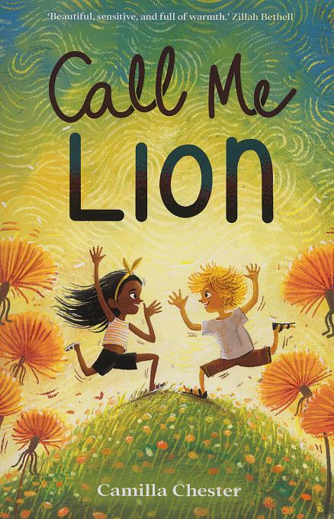 | 9781913102890  Selective Mutism | Call Me Lion  AR: 4.7 MY  BB: Dark Blue | Chester, Camilla | £7.99
 | 9781848126169  Downs Syndrome | A Storm of Strawberries  AR: 4.1 MY  BB: Dark Red | Cotterill, Jo | £6.99
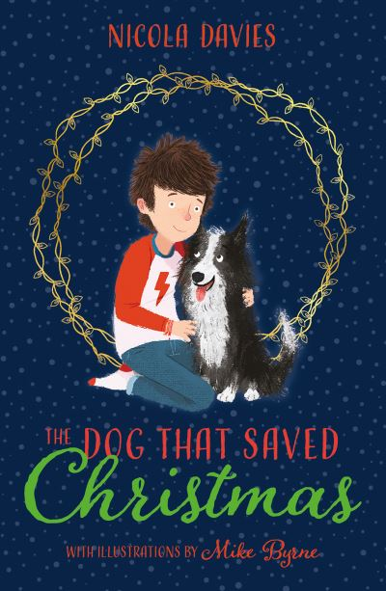 | 9781781127698  ASD | The Dog That Saved Christmas  AR: 4.0 MY | Davies, Nicola | £7.99
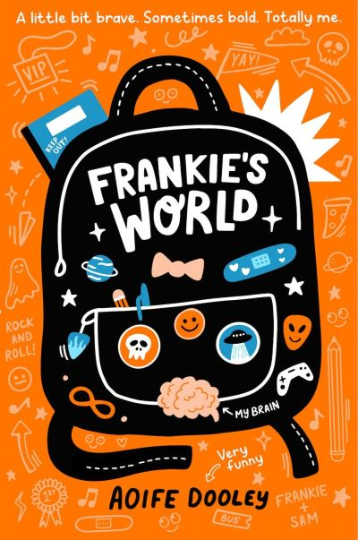 | 9780702307355  ASD | Frankie's World  Graphic  AR: 2.8 MY | Dooley, Aoife | £8.99
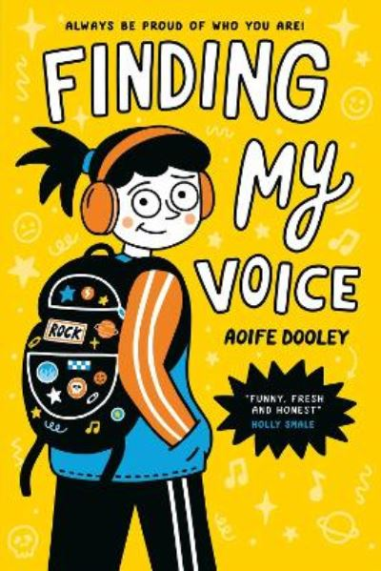 | 9780702307386  ASD | Finding My Voice  AR: 2.6 MY | Dooley, Aoife | £8.99
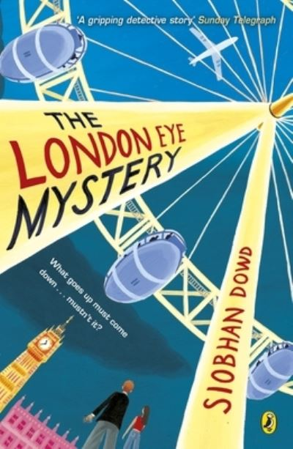 | 9780141376554  ASD | The London Eye Mystery  AR: 4.1 MY  BB: Dark Blue | Dowd, Siobhan | £7.99
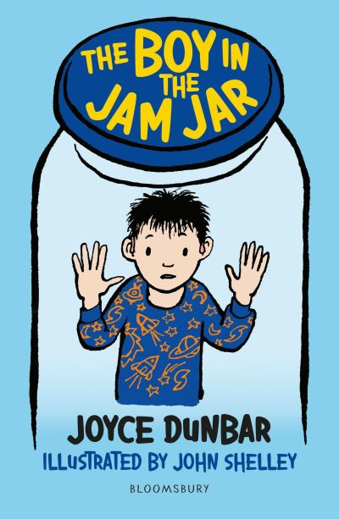 | 9781472973931  H I | The Boy in the Jam Jar  AR: 3.9 LY  BB: Lime | Dunbar, Joyce | £6.99
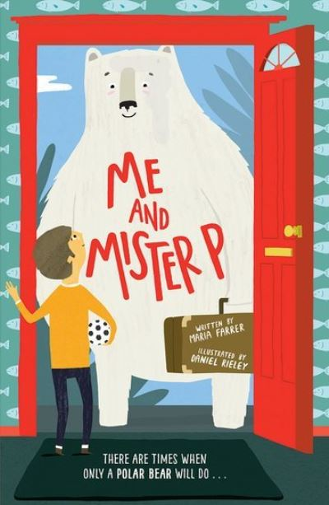 | 9780192744210  ASD | Me and Mister P  AR: 4.8 LY  BB: Grey/Black | Farrer, Maria | £6.99
 | 9781406399240  ASD | Paws | Foster, Kate | £6.99
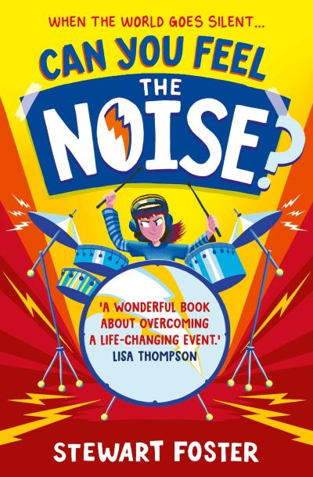 | 9781471191275  H I | Can You Feel the Noise?  AR: 4.5 MY  BB: Dark Blue | Foster, Stewart | £7.99
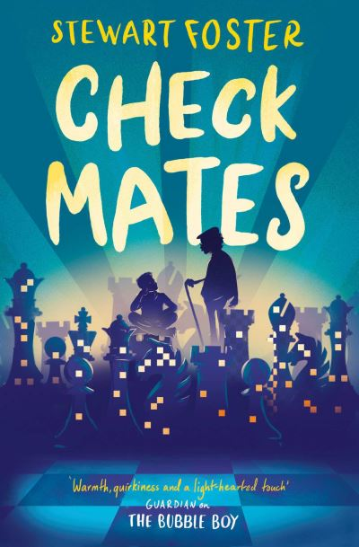 | 9781471172236  ADHD | Check Mates  AR: 4.0 MY  BB: Dark Red | Foster, Stewart | £7.99
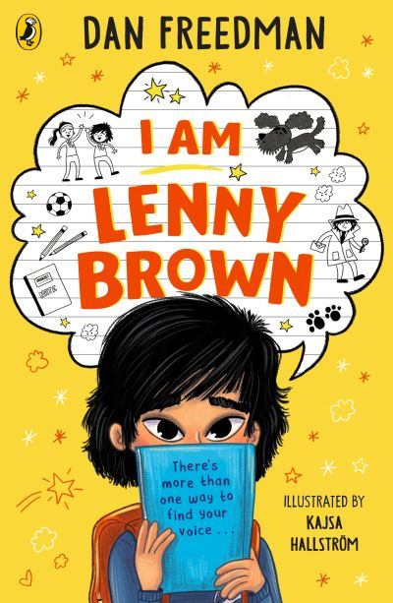 | 9780241610541  Elective Mutism | I Am Lenny Brown  AR: 4.4 LY  BB: Brown | Freedman, Dan | £7.99
 | 9781444958379  Cerebral Palsy | The Big Trip  BB: Dark Red | Jones, Rosie | £7.99
 | 9780861542055  ASD | The Extraordinary Adventures of Alice Tonks  BB: Dark Red | Kenny, Emily | £7.99
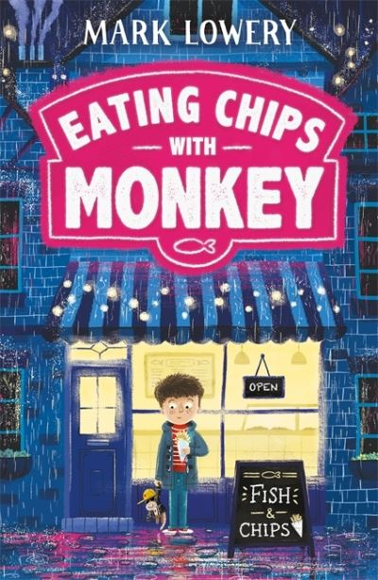 | 9781848127371  ASD | Eating Chips with Monkey  BB: Dark Blue | Lowery, Mark | £6.99
 | 9780702314988  Achondroplasia | I Got This  BB: Dark Red | Mailey, Cara | £6.99
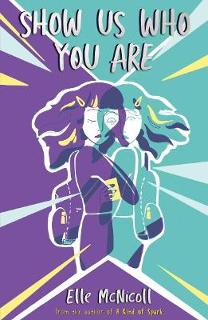 | 9781913311131  ASD/ADHD | Show Us Who You Are  AR: 4.3 MY  BB: Dark Red | McNicoll, Elle | £7.99
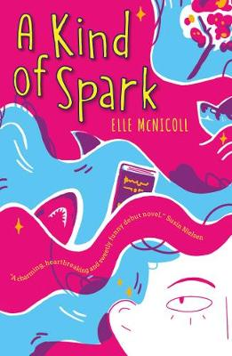 | 9781913311056  ASD | A Kind of Spark  AR: 4.3 MY  BB: Dark Blue | McNicoll, Elle | £7.99
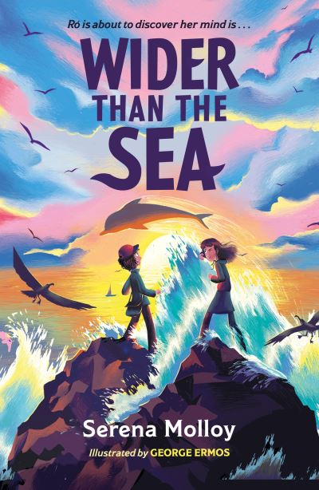 | 9781444968415  Dyslexia | Wider than the Sea  AR: 5.3 MY | Molloy, Serena | £7.99
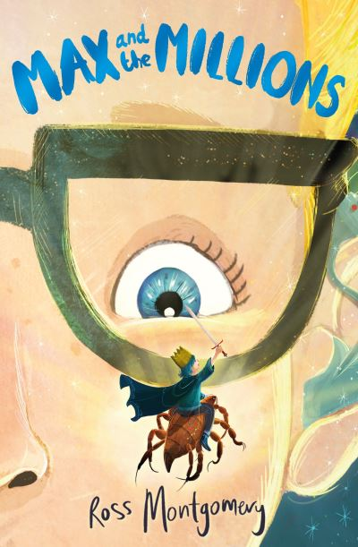 | 9780571333486  H I | Max and the Millions  AR: 4.4 MY  BB: Dark Blue | Montgomery, Ross | £7.99
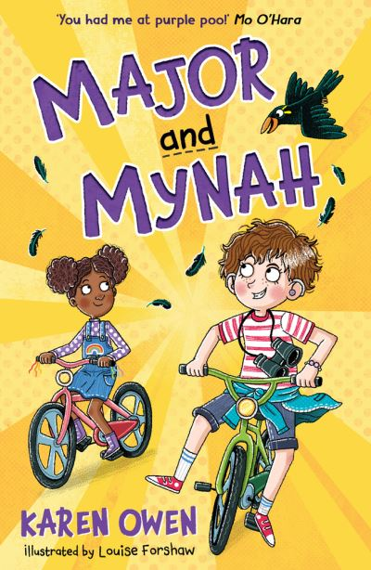 | 9781913102746  H I | Major and Mynah  BB: Brown | Owen, Karen | £6.99
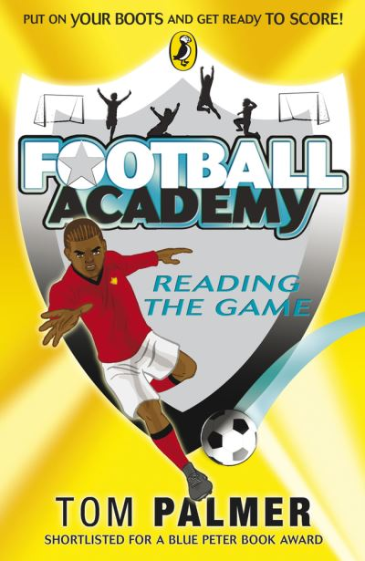 | 9780141324708  Dyslexia | Reading the Game  AR: 3.5 LY | Palmer, Tom | £7.99
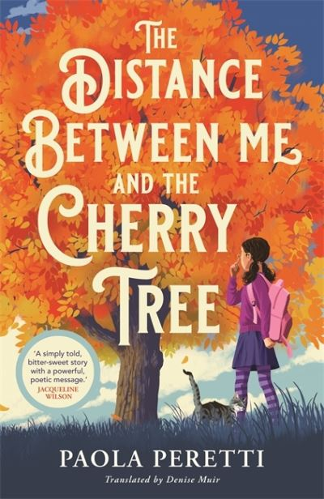 | 9781471407550  V I | The Distance Between Me and the Cherry Tree  AR: 4.5 MY  BB: Dark Red | Peretti, Paola | £7.99
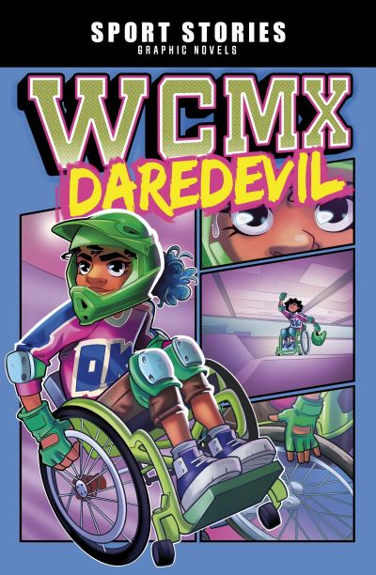 | 9781398242654  Physical Disability | WCMX Daredevil  Graphic novel  AR: 2.5 MY  BB: Dark Blue | Pryor, Shawn | £8.99
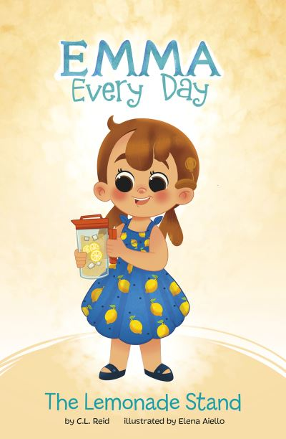 | 9781398233744  H I | The Lemonade Stand  AR: 2.6 LY  BB: Turquoise | Reid, C L | £5.99
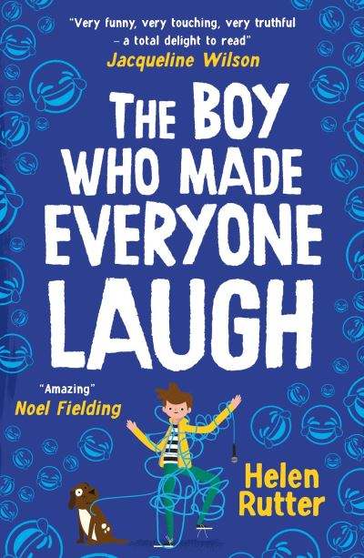 | 9780702300851  Speech | The Boy Who Made Everyone Laugh  AR: 4.9 MY  BB: Dark Blue | Rutter, Helen | £7.99
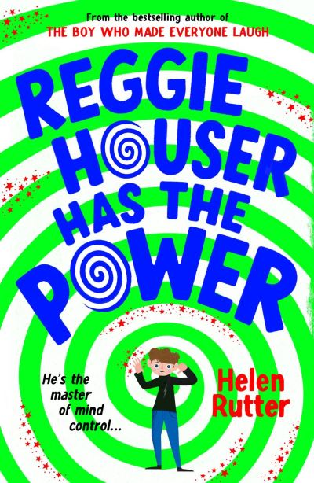 | 9780702314650  ASD | Reggie Houser has the Power  BB: Dark Blue | Rutter, Helen | £7.99
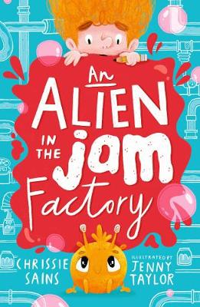 | 9781406396126  Cerebral Palsy | An Alien in the Jam Factory  BB: Grey | Sains, Chrissie | £6.99
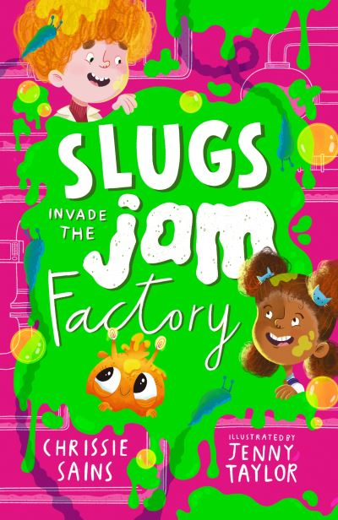 | 9781529510683  Cerebral Palsy | Slugs Invade the Jam Factory  BB: Grey | Sains, Chrissie | £6.99
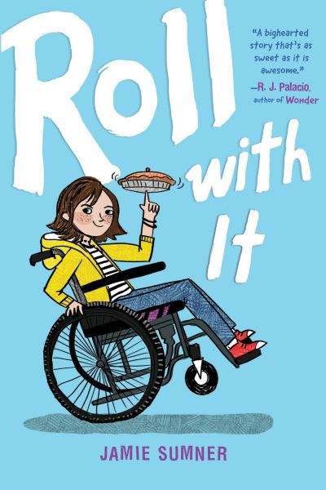 | 9781534442566  Cerebral Palsy | Roll with It  BB: Dark Blue | Sumner, Jamie | £7.99
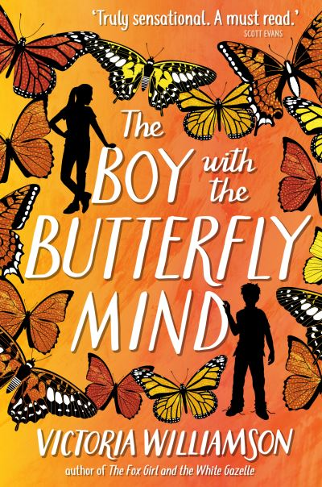 | 9781782506447  ADHD | The Boy with the Butterfly Mind  AR: 5.5 MY+  BB: Dark Red | Williamson, Victoria | £7.99
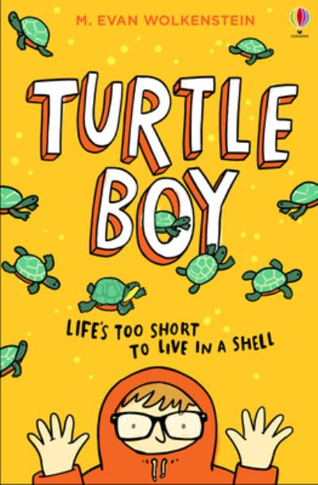 | 9781474981385  Physical Disability | Turtle Boy  AR: 4.4 MY  BB: Dark Red | Wolkenstein, M Evan | £7.99

