|  |  |
| --- | --- |
| **‘In the Bleak Midwinter’ (A Christmas Carol)**  **Christina Rossetti**  Publisher: **Online at** [**A Christmas Carol | The Poetry Foundation**](https://www.poetryfoundation.org/poems/53216/in-the-bleak-midwinter) **and widely available online elsewhere (originally c.1872)** | **2 guided sessions** |
|  |
| This guided reading session is based on understanding a Christmas carol. There are other *Re-think Reading!* plans available for Year 1, Year 3/4 and Year 5/6 based on different carols. The content of this plan should be accessible for children who are in later phonics phases or who have some vowel digraphs and who are starting to understand the concept of a digraph having more than one pronunciation. The focus of these sessions is to become familiar with archaic language and understanding what you are singing about when you sing this carol.  To make the most of this session, a nativity scene is necessary. This can be a real one or can be made up out of stick puppets. An internet search will return many examples that can be used. Just make sure you have enough angels to make a throng! | |

|  |  |
| --- | --- |
| **Books by the same author** | **Linked texts** |
| ‘Colour’  ‘Caterpillar ("Brown and furry")’  ‘Who Has Seen the Wind?’  Several of Rossetti’s poems are available from the Poetry Foundation: [Christina Rossetti | The Poetry Foundation](https://www.poetryfoundation.org/poets/christina-rossetti) | *What Can I Give Him?* (1998) or *Give Him My Heart* (1999) by Debbie Gliori. These are the same books but with different titles.  Children singing the carol can be seen here: <https://www.youtube.com/watch?v=o3zW2TYjmiQ>  Susan Boyle singing In the Bleak Midwinter: <https://www.youtube.com/watch?v=r_dO91hQhkU> |

|  |  |
| --- | --- |
| **National Curriculum Programme of Study** | |
| **Word reading** | |
|  | **continue to apply phonic knowledge and skills as the route to decode words until automatic decoding has become embedded and reading is fluent** |
|  | * Reading the carol several times for different purposes * Rereading enough to develop fluency |
|  | **re-read these books to build up fluency and confidence in word reading** |
| **Comprehension** | |
| **develop pleasure in reading, motivation to read, vocabulary and understanding:** | |
|  | **discuss and clarify the meanings of words, linking new meanings to known vocabulary** |
|  | **continue to build up a repertoire of poems learnt by heart, appreciating these and reciting some, with appropriate intonation to make the meaning clear** |
|  | * Learning the carol off by heart * Reading or singing the carol |
| **understand both the books they can already read accurately and fluently and those they listen to:** | |
|  | **check that the text makes sense to them as they read, and correct inaccurate reading** |
|  | * Clarifying new vocabulary * Matching new vocabulary to images * Zooming in and out |
|  | **answer and ask questions** |
|  | * Answer and ask questions generated by the teacher and the group |

|  |
| --- |
| **Pre-reading task**  You may be singing this carol as part of a nativity or Christmas assembly. It does not matter if the children have started to learn it or whether it is new to them. |

**Session 1**

|  |  |
| --- | --- |
| **Book Introduction** | **Prepare the poem by cutting it into verses with the title also separate.**  If you are using the book by Gliori, there is no need to do this.  Share the word cards (see Resources below) and ask the children in pairs to put sound buttons onto the words and then sound them out. You can do this as one group or work in pairs and then share.   * Explain that there are several words that are types of angel. Place the word ‘angel’ on the picture or near a model of an angel and children work out in pairs which words they think are also types of angel (archangel, cherubim and seraphim - these are the plurals of ‘cherub’ and ‘seraph’). Children say the words and place them on the picture of an angel. * Show the picture of a bleak landscape and ask the children to say what it looks like. Explain that when something is ‘bleak’ it is cold and miserable. Place the word by the picture. * Discuss the fact that iron can have two meanings. If possible, have an example of the metal and what it feels like – cold and hard. What might be like iron in winter? * Jumble the words up and ask children to read them and then place them next to the object/picture that shows their meaning. * Explain what ‘thronged’ (gather in great numbers) and ‘worshipped’ (show respect to a god) mean and relate to the children’s lives. When do they throng/worship? |
| **Strategy Check** | When you read, you need to check that it is making sense. What will you do if you come to a word you are not sure about?   * Sound it out. * Read to the end of the sentence. * Go back and read the whole sentence again.   As you read, build a picture in your head of what is happening. |
| **Independent Reading** | Children read the first verse out aloud at their own pace. |
| **Respond to Text** | Discuss:   * What was the winter like? * Which words and phrases tell us this? * How would you be feeling in this place? |
| **Independent Reading** | Give pupils the second verse. Children read it aloud at their own pace. |
| **Respond to Text** | Count two lines and draw a star at the end of the second line. Model thinking aloud when reading the first two lines, sharing the types of thoughts and questions you have as you read. This is called zooming in and zooming out. Ask children to do the same for the next two lines.  Discuss:   * What do you think has happened? * When did angels gather at this time of year? (Relate to what children know of the Christmas story) * Who might ‘the Beloved’ be? * Why might his mother kiss him?   Use images of the nativity or nativity models and ask children to create the scene as they understand it from the verse, |

|  |
| --- |
| **Post-session task**  Stick the first 2 verses in reading journals.  Inference: Draw a picture to show what happened in each verse. |

**Session 2**

|  |  |
| --- | --- |
| **Book Introduction** | Share pictures created in the post-session task. How are they the same and different? |
| **Strategy Check** | When you read, you need to check that it is making sense. What will you do if you come to a word you are not sure about?   * Sound it out. * Read to the end of the sentence. * Go back and read the whole sentence again. * You may want to zoom in and out. * Think about what would make sense.   As you read, build a picture in your head of what is happening. |
| **Independent Reading** | Pupils read the third verse out aloud at their own pace. |
| **Respond to Text** | What is happening in this verse?   * Who does ‘Him’ refer to? * Why are people bringing him presents? * What might different people bring to Jesus? * Why might you bring him your heart? What are you bringing if you bring your heart?   Provide a set of question words on cards (see Resources below). Turn over the top card and children generate a question starting with the word that can be answered in the text. Provide an opportunity for children to ask their questions to the group who can answer them.  In pairs, practise reading a verse of the carol fluently and share with the group. The children could prepare this to share with the class. |

|  |
| --- |
| **Post-session task**  Learn the words of the carol off by heart ready to sing. |

**Resources**

**In the Bleak Midwinter**

In the bleak mid-winter

Frosty wind made moan;

Earth stood hard as iron,

Water like a stone;

Snow had fallen, snow on snow,

Snow on snow,

In the bleak mid-winter

Long ago.

Angels and Archangels

May have gathered there,

Cherubim and seraphim

Thronged the air;

But only His Mother

In her maiden bliss

Worshipped the Beloved

With a kiss.

What can I give Him,

Poor as I am?

If I were a Shepherd

I would bring a lamb;

If I were a Wise Man

I would do my part,

Yet what I can I give Him,

Give Him my heart.

**Word cards and images to match**

|  |  |  |
| --- | --- | --- |
| **bleak** | **iron** | **archangel** |
| **angel** | **cherubim** | **seraphim** |
| **thronged** | **shepherd** | **worshipped** |

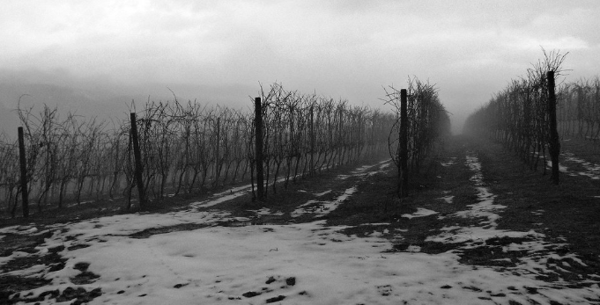

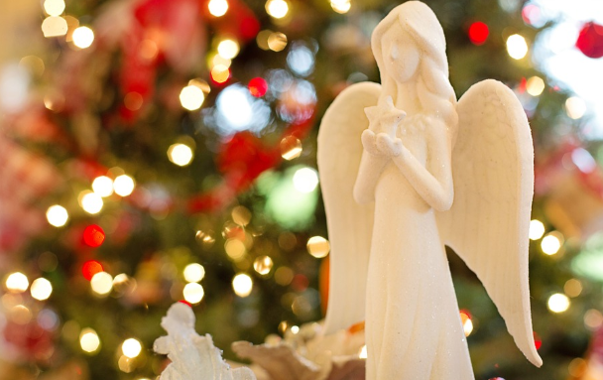

(images free to use)

**Question words**

|  |  |  |
| --- | --- | --- |
| **who** | **what** | **where** |
| **when** | **why** | **how** |