Finn MacCool and the Giant's Causeway  Oxford Reading Tree Traditional Tales, Stage 8  John Dougherty and Lee Cosgrove  Publisher: OUP Oxford (2011)  ISBN: 978-0198339755 | 3 guided sessions
 | 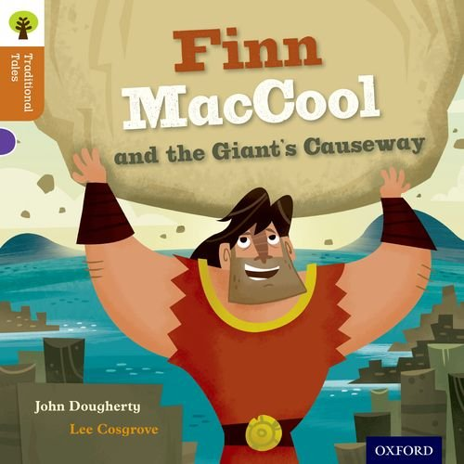
This is the traditional story of Finn MacCool, told using great vocabulary and with images that really support the understanding of the story.

Books by the same author | Linked texts
There are many lovely traditional tales in this series. | Information texts about the Giant’s Causeway

National Curriculum Programme of Study
Word reading
continue to apply phonic knowledge and skills as the route to decode words until automatic decoding has become embedded and reading is fluent
read accurately words of two or more syllables that contain the graphemes taught so far, especially recognising alternative sounds for graphemes
- Reading the text independently
Comprehension
develop pleasure in reading, motivation to read, vocabulary and understanding:
discuss and clarify the meanings of words, linking new meanings to known vocabulary
- Clarifying vocabulary each session
understand both the books they can already read accurately and fluently and those they listen to:
draw on what is already known or on background information and vocabulary provided by the teacher
- Clarify vocabulary
make inferences on the basis of what is being said and done
- Inferring about characters’ feelings in chapter 2 and 3
- Discussing how they change
predict what might happen on the basis of what has been read so far
- Predicting how the story will develop

Session 1
Book Introduction | Show the story map from the back of the book.  Predict what you think the story will be about. Can they infer about feelings of characters? Why might they feel like that?  Introduce the title: continue to predict. What sort of story is it going to be? Talk about predicting and what it means.  Look at the title page. Predict who you think this is. Does it make you change your predictions?  Have a quick look at the first pages and discuss ideas and how these change or confirm our predictions.  Read p.2 and p.3 together. Predict the rest of the story.  Practise blending some of the key words to focus on decoding (see resources).  Do these words make us predict anything different about the story?
Strategy Check | What will you do if you get stuck?  - Sound out and blend the word.  - Think of a word that would make sense.  - Re-read the sentence from the beginning.  - Use the picture to support you.  I want you to keep thinking about the story and if there are any words you don’t understand let me know at the end.
Independent Reading | Read aloud at own pace up to p.10 (you might need to paperclip the other pages to stop them cheating!).
Respond to Text | Clarify: are there any words or things that happen in the story that you aren’t sure about? Model this if the children don’t mention anything. Possible words might be cupping, bellowed, bonnet, nightgown.  Check meaning: tell me about what is happening in the story. Clarify any confusion.  Predict to end. What do you think will happen next?

Post-session task
This would be a good point to break the session and children could write about how they think the story will end as a post session task.

Session 2
Book Introduction | Share the children’s ideas from their writing about how the story might end.  Look for similarities and challenge children to justify their ideas with reference to the text.
Strategy Check | What will you do if you get stuck?  - Sound out and blend the word.  - Think of a word that would make sense.  - Re-read the sentence from the beginning.  - Use the picture to support you.  I want you to keep thinking about the story and if there are any words you don’t understand let me know at the end.
Independent Reading | Read to the end of Chapter 2 on your own quietly to yourself.
Respond to Text | Identify any words or ideas that need to be clarified. Possible tricky words include snarled, nervous, gulped, heaved.  As you clarify the vocabulary, discuss what each word adds to our understanding of the story. All of these words tell us something about how a character is feeling.  Use pictures or write the name of each character on cards: looking back through chapter 2, find evidence to show us what each character is thinking and feeling. Write ideas on cards and match to character.  Predict: do children think any of the characters will change how they feel in the next chapter?

Post-session task
Read to the end of the book on your own or with a partner. Make a note in your reading journal of any words we need to clarify and anything you notice about how the characters change.

Session 3
Respond to Text | Share the children’s tricky words or phrases to clarify. Possible ones might be howled, face turned pale, tearing up, wonders of the world.  As a group re-tell the ending of the story to ensure that everyone has understood the key plot events. Clarify if they have not.  Return to the characters and the words we had in the last session to describe their feelings. Are they the same in the last chapter? Do they change at all? Add more words to describe any changes.

Post-session task
Use the story map from the book to write a retelling of the story of Finn MacCool. Children could tell this orally and record, if writing is a barrier.

Other independent activities based on the book
- Read other traditional stories from Oxford University Press.
- Research information about the Giant’s Causeway.

Resources

Title of resource
Ireland | mighty
dozen | feared
boasting | angrily
heard | roared
breeze | giant
County Antrim

